Physics-Guided Machine Learning for Generalizable Critical Heat Flux Prediction Under Diverse Thermal-Hydraulic Conditions

Abstract
Critical heat flux marks the point at which a boiling surface can no longer be cooled fast enough, and in a nuclear reactor it defines the operating margin between safe heat removal and cladding damage. Because this limit depends on fluid, geometry, pressure, and surface condition in ways that resist simple physical derivation, it has traditionally been estimated through empirical correlations and look-up tables built from decades of experimental data. Machine learning offers an alternative route to this prediction problem, but existing data-driven approaches are typically trained and validated under a single set of conditions, leaving it unclear how they behave when applied beyond the data they were trained on. This work develops a machine learning pipeline for critical heat flux prediction intended to generalize across fluids, geometries, and surface conditions without being redesigned or retrained for each new case. A merged experimental database spanning a range of boiling regimes and heating configurations is used to compare several modelling strategies, including neural network and attention-based architectures, ensemble tree methods, and a physics-informed formulation, evaluated not only on randomly held-out data but under stricter splits that withhold entire conditions, surfaces, and data sources. The comparison shows that purely data-driven models, however accurate under easy conditions, can degrade sharply once conditions depart from their training distribution, whereas anchoring predictions to an established physical correlation and using a learned model only to refine that baseline preserves stable, bounded behaviour even in previously unseen regimes. The resulting hybrid approach is intended as a general-purpose, trustworthy foundation for critical heat flux estimation, with future extension toward interpreting which physical parameters drive its predictions.
Keywords: Critical heat flux; Machine learning; Physics-guided modelling; Distribution shift; Nuclear thermal-hydraulics

1. Introduction
Nuclear reactors generate enormous amounts of heat inside a very small volume, and the only thing standing between that heat and a serious accident is the coolant's ability to carry it away fast enough. In water-cooled reactors, this heat removal happens mostly through boiling: as water flows past the hot fuel surface, it picks up energy and starts forming vapor bubbles that carry heat away far more efficiently than the flowing liquid alone. This process, called nucleate boiling, is remarkably good at removing heat, but only within a limit. Push the heat flux higher, and there comes a point where the bubbles at the surface stop escaping efficiently, start merging into an insulating vapor layer, and the wall temperature spikes almost instantly. This tipping point is the Critical Heat Flux (CHF), and it represents the ceiling on how much heat a boiling surface can safely handle.
In pressurized water reactors (PWRs), this same phenomenon is usually described as Departure from Nucleate Boiling (DNB): the fuel surface loses direct contact with the liquid and gets blanketed by a vapor film. In boiling water reactors (BWRs), where a large fraction of the coolant is already vapor by the time it reaches the top of the core, the equivalent failure mode is dryout, where the thin liquid film clinging to the fuel rod simply runs out and the surface is left dry. Different names, same underlying danger. Once CHF is exceeded, the heat transfer coefficient collapses by an order of magnitude or more, and the fuel cladding temperature can rise by hundreds of degrees within seconds. If sustained, this can damage or fail the fuel cladding, which is precisely the barrier that keeps radioactive material contained. This is why CHF is not just a thermal hydraulics curiosity; it is one of the defining safety limits that governs how much power a nuclear reactor is allowed to produce.

Why Predicting CHF Matters
Because CHF sets a hard ceiling on reactor operation, being able to predict it accurately, across the full range of pressures, flow rates, and geometries a reactor might see, is essential, and the consequences of getting it wrong run in both directions. Underestimate CHF, and a plant is operated more conservatively than it needs to be, at the cost of power output and efficiency. Overestimate it, and the margin to a real safety limit shrinks or disappears, which is obviously the more dangerous mistake. Accurate CHF prediction is essential in the following areas namely, nuclear reactor fuel cooling. CHF sets the fundamental thermal limit on how much power a fuel assembly can safely generate before the cooling mechanism itself breaks down. Pressurized water reactors (PWRs). CHF prediction directly determines the minimum DNB ratio a plant must maintain during both normal operation and postulated accidents, shaping core design and operating limits from day one. Boiling water reactors (BWRs). Dryout prediction plays the equivalent role here, defining the critical power that a fuel bundle can sustain. Accident-tolerant cooling concepts. New cladding materials, coatings, and enhanced surfaces designed to buy operators more time during a loss-of-coolant event all need to be evaluated against how they shift the CHF limit, so any new design has to be tested against, or predicted by, a reliable CHF model before it can be trusted in a real core. High-heat-flux thermal systems. Beyond nuclear reactors, the same underlying physics governs the limits of any high-heat-flux boiling system, from electronics cooling to industrial boilers, which makes CHF prediction a problem whose stakes extend well past the nuclear industry alone.

Limitations of Conventional CHF Correlations
Given how much depends on getting this number right, the natural question is how CHF is predicted in practice today. For decades, the standard tools have been empirical correlations and look up tables, such as the widely used 2006 Groeneveld look up table, built by fitting mathematical relationships directly to large collections of experimental measurements. These correlations work, and they have served the industry for decades, but they carry a specific set of limitations that are worth naming individually, since each one shapes exactly where a data driven alternative could help. Empirical nature. Correlations such as the Groeneveld look up table are curve fits to measured data, not derivations from a physical model of the boiling crisis. The functional form used, often a power law or a piecewise multiplicative combination of pressure, mass flux, and quality, is chosen because it fits the available data reasonably well, not because it follows from the underlying physics of bubble growth, microlayer evaporation, or vapor escape. This means the correlation carries no built in understanding of why CHF happens, only a description of what it looked like in the specific experiments it was fitted to. Narrow experimental ranges. Every correlation is only as good as the data it was built from, and that data was collected within a specific window of pressure, mass flux, quality, and tube diameter. Even the 2006 Groeneveld look up table, despite being one of the broadest CHF databases ever assembled, still contains entire regions that are interpolated or extrapolated rather than measured directly, simply because no experiment has ever been run at every combination of conditions a reactor could see. Dependence on specific fluids. Correlations built from water data do not transfer cleanly to other fluids, even when the flow conditions look similar on paper. Pioro et al. (2002) compared CHF under matched flow conditions for water and for R-134a, a common refrigerant used as a water surrogate in scaled experiments and found that the effect of surface orientation on CHF was measurably stronger for R-134a than for water under otherwise equivalent conditions. A correlation tuned only on water data has no way of knowing this discrepancy exists, let alone correcting for it. Dependence on geometries: a CHF correlation built for one channel geometry, a round tube, an annulus, a rod bundle, does not automatically apply to another. The usual fix is a geometry correction factor, but even this correction is not constant. Tanase et al. (2009) tabulated a diameter correction exponent for CHF across 24 separate combinations of pressure, mass flux, and quality, and found the exponent itself ranging from about minus 0.3 to plus 0.6 depending on which regime a given condition fell into. In other words, there is no single number that describes how CHF scales with tube diameter, only a patchwork of regime specific values. Difficulty incorporating surface characteristics. As the next section describes in detail, conventional correlations are built almost entirely around bulk flow variables, pressure, mass flux, and quality, and have no natural input slot for surface roughness, wettability, coating, or material. A correlation can be refit for one specific engineered surface, but it cannot generalize to a new surface it has never seen, because surface condition was never part of its functional form to begin with. Poor extrapolation: Because these correlations are fitted rather than derived, they interpolate well within their original database and extrapolate poorly outside it. Step into a new fluid, an unusual diameter, or a pressure range with little experimental coverage, and a correlation can degrade sharply or fail outright, precisely because it has no mechanistic understanding of the boiling crisis to fall back on once the data runs out. Nonlinear coupling among parameters: CHF does not respond to pressure, mass flux, diameter, and quality independently. It responds to specific combinations of them, and the way these parameters interact changes from one flow regime to another. The same Tanase et al. (2009) diameter exponent data make this concrete: the exponent describing how CHF scales with diameter is not one number but 24 different numbers, each valid only for a specific combination of pressure, mass flux, and quality. Capturing this kind of regime dependent, multi parameter interaction with a single tidy equation is exactly the sort of problem that empirical correlations, built around simple multiplicative forms, are poorly suited to represent. This gap between the conditions a real reactor might encounter and the narrow, fluid specific, geometry specific window a correlation was actually validated against is exactly the opening that data driven and machine learning methods have started to fill, and it is the motivation behind the growing body of CHF research summarized in Figure 1.
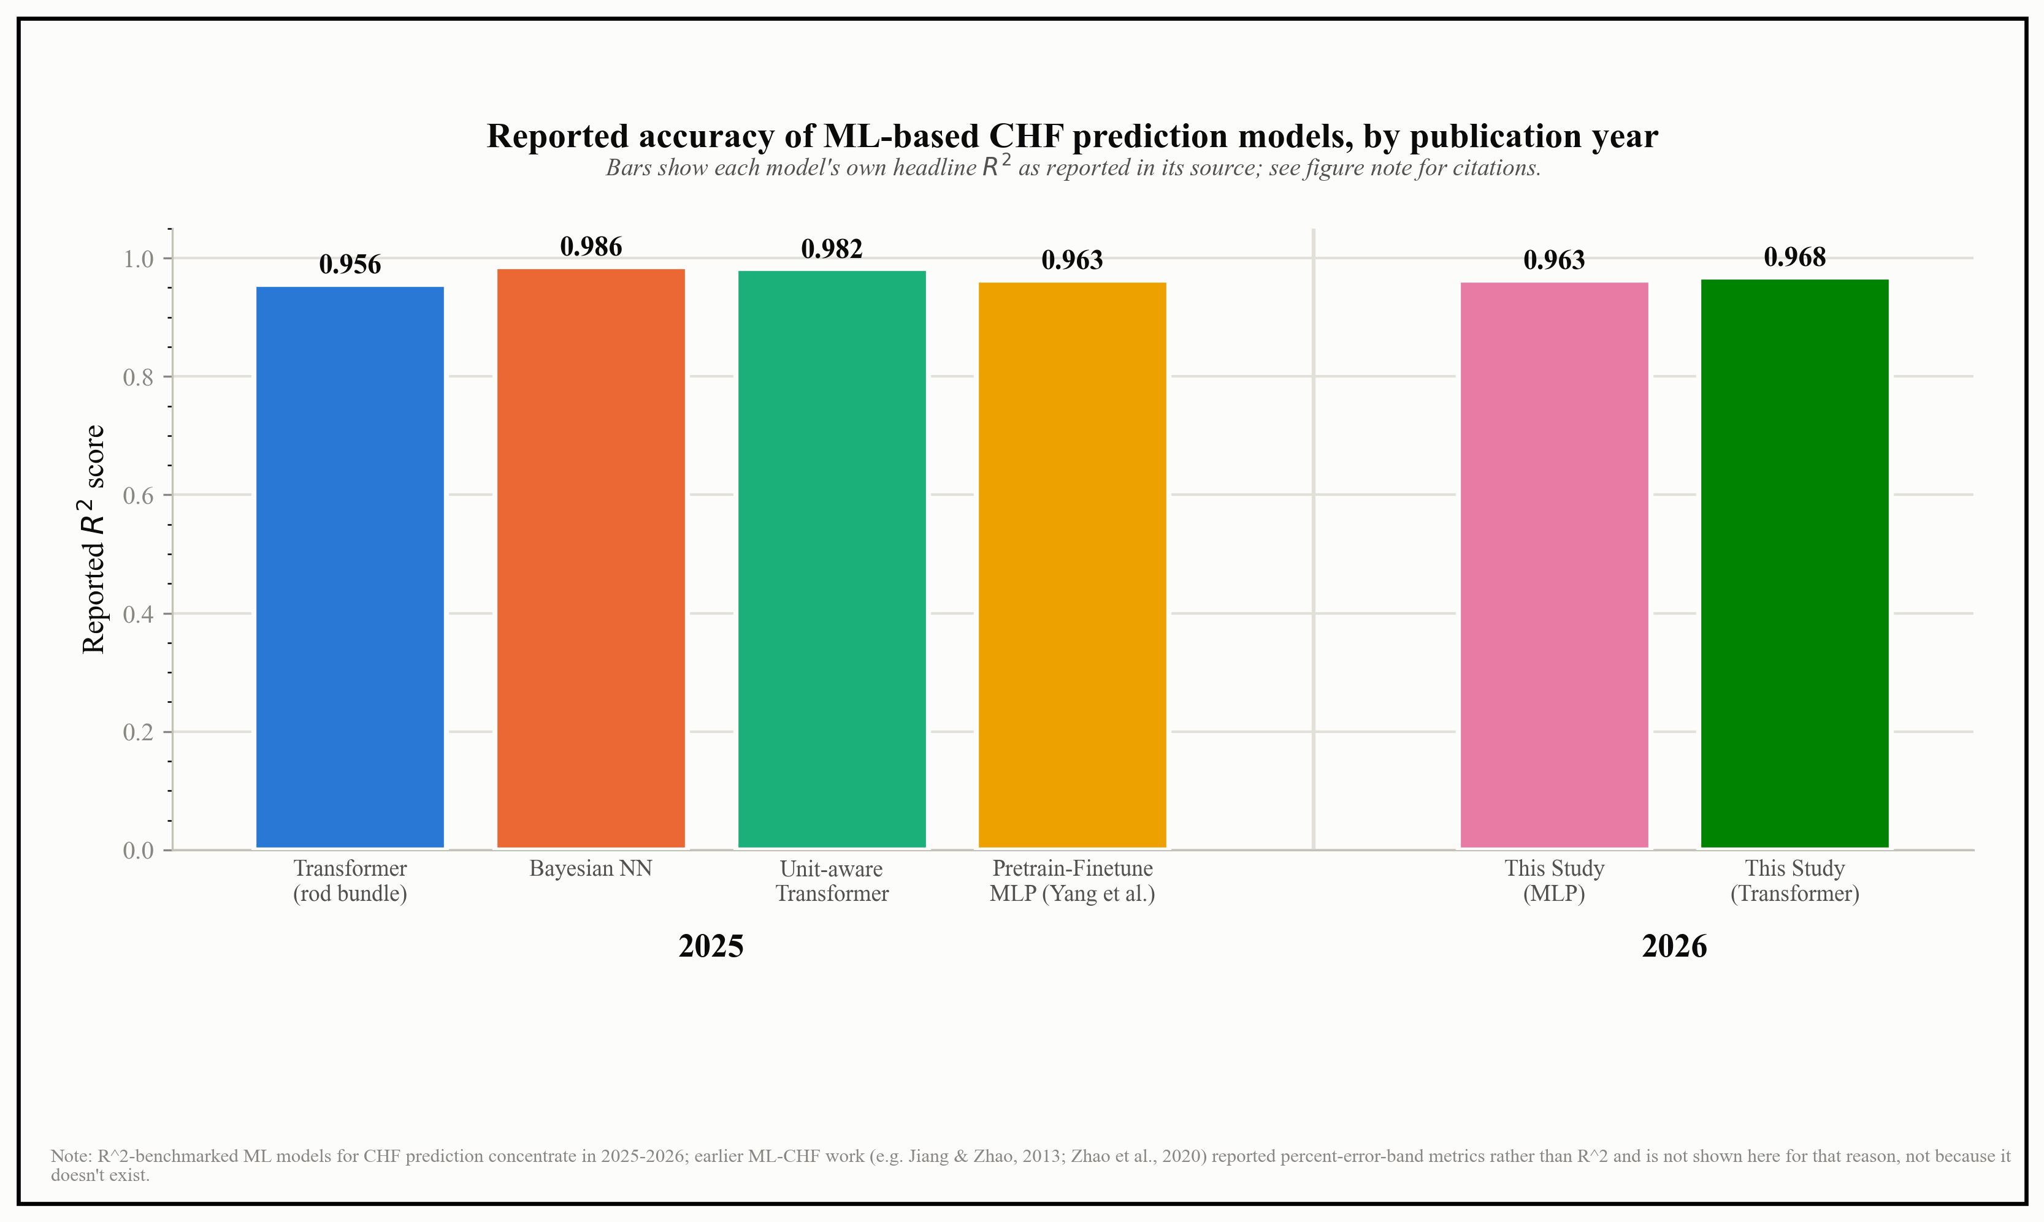
Figure 1. Reported R-squared accuracy of machine-learning-based CHF prediction models by publication year (2025 to 2026), including this study's results. Sourced from Yang et al. (2025), a physics-informed hybrid comparative study (2025), a Bayesian neural network study (2025), a unit-aware embedding Transformer study (2025), and this study's own pretrained and fine-tuned MLP and Transformer models (2026). See docs/manuscript/chf_ml_trends_data.csv for the full sourced dataset.

Machine Learning as a Potential Solution
Machine learning offers a genuinely different way of building a CHF model, and it is worth being precise about exactly which of the seven limitations above it addresses directly, which it improves only partially, and which it does not solve just by virtue of being machine learning. Taken point by point against the same list, Empirical nature. Machine learning models are also fitted to data rather than derived from first principles, so in a strict sense they do not remove the empirical nature of CHF prediction. What changes is the flexibility of the fit. A correlation is locked into a functional form chosen in advance, usually a power law or a fixed multiplicative combination, while a neural network can represent a much wider family of shapes, including sharp transitions and interactions that a person would not think to write down as a single equation. This project's own models reached an R-squared of 0.963 (MLP) and 0.968 (Transformer) under interpolation testing, a level of fit that a fixed-form correlation is not built to achieve across such a wide range of conditions at once. Narrow experimental ranges. Merging many independent datasets into one much larger training set directly widens the range of conditions a model has actually seen. A collaborator on this project combined seven independent CHF sources into a single 28,470 row dataset spanning tubes, annuli, helical coils, and pin-fin surfaces, a far broader coverage than any single correlation's original database. This genuinely helps, but it is worth being honest about what it does not do: it pushes the boundary of the covered range outward, it does not remove the boundary. A model trained on this larger dataset can still only interpolate within it. Dependence on specific fluids. Rather than needing a separate correlation refit for every fluid, a machine learning model can take fluid properties directly as input features, things like reduced pressure or other dimensionless groups that describe a fluid's thermodynamic state relative to its critical point. This project's own feature set is built this way, and the per domain fine-tuning results, R-squared values ranging from about 0.48 to 0.91 depending on the fluid and geometry combination, show a single underlying model architecture adapting across genuinely different fluids, rather than requiring a separate hand-built correlation for each one. This solution carries its own honest caveat, discussed further in Section 1.8: the same dimensionless representation that lets a model transfer across fluids can also make an unseen fluid look, numerically, like one the model has already seen, which is a real cost of this approach and not a minor detail. Dependence on particular geometries. The same logic applies to geometry. Instead of a single diameter correction exponent applied uniformly, a model can take geometry descriptors, diameter, geometry family, hydraulic diameter, as direct inputs and learn how CHF depends on them jointly with the flow conditions, rather than through a bolted-on correction factor. The cross-geometry fine-tuning results from this project's own testing, spanning five different geometry and fluid combinations, are a direct test of this idea. Difficulty incorporating surface characteristics. Surface descriptors, roughness, contact angle, coating type, can simply be added as extra columns in the input data, something a bulk flow correlation has no mechanism for at all. The pin-fin pool-boiling dataset used in this project's own testing includes exactly this kind of surface-specific information, and a model trained on it can, in principle, learn how CHF shifts with surface condition directly from the data rather than needing a person to encode that relationship by hand. Poor extrapolation. This is the point where it is important not to overclaim. Plain machine learning does not fix poor extrapolation just by being machine learning; in several respects it can be worse than a classical correlation outside its training range, since a neural network has no physical constraint forcing it to behave sensibly once it leaves the data it was trained on. Under a hard pressure-based extrapolation split, this project's own testing found random-forest and gradient-boosted tree models collapsing to an R-squared of roughly 0.41 to 0.45, and a separate pretrain-and-fine-tune transfer learning study reported a standard neural network reaching a negative R-squared of minus 6.56 under a comparable pressure-based extrapolation test. What actually helps is a more deliberate training strategy, not simply switching from a correlation to a neural network. This project's own model, pretrained on a large synthetic dataset spanning a wide parameter space and then fine-tuned on real experimental data with a deliberately held-out high-pressure extrapolation region, reached an R-squared of 0.916 (MLP) and 0.953 (Transformer) on that held-out extrapolation test, far above the tree-based results under the same split. Yang et al. (2025) report a similar pattern, reaching an R-squared of 0.9632 with a physics-informed hybrid approach rather than a plain data fit. The lesson is specific rather than general: machine learning does not solve extrapolation automatically, but pretraining, transfer learning, and physics-informed structure, used deliberately, can measurably narrow the gap in a way that neither a classical correlation nor a naively trained neural network achieves on its own. Nonlinear coupling among parameters. This is arguably where machine learning has the clearest structural advantage. A neural network is, by construction, a universal function approximator: it does not need a person to pre-specify how pressure, mass flux, diameter, and quality interact, or to split the parameter space into 24 separate regimes the way the Tanase et al. (2009) diameter exponent table does. It learns the interactions directly from the data. The practical result in this project's own testing is a single model, not two dozen regime-specific equations, reaching an R-squared above 0.96 on interpolation testing across the full combined range of pressure, mass flux, quality, and diameter, without any manual splitting of the parameter space into separate regimes.
None of this means machine learning is a drop-in replacement for physical understanding, or that it should be trusted blindly outside the range of conditions it has actually seen. But point by point, it directly addresses five of the seven limitations above, fluid dependence, geometry dependence, surface characteristics, nonlinear coupling, and to a real extent the narrow-range problem, offers a genuine but carefully qualified improvement on a sixth, poor extrapolation, when combined with pretraining and transfer learning rather than used naively, and is honest, rather than evasive, about the seventh, its own empirical nature. That is the case, grounded in the results already discussed above and summarized in Figure 1, for treating machine learning as a genuinely promising direction for CHF prediction, rather than as a buzzword substitute for the correlations it is trying to improve on.

Existing ML-based CHF Prediction
With the case for machine learning established, it is worth looking at what has actually been tried so far. Over roughly the last decade and a half, a fairly consistent set of algorithms keeps showing up across the CHF literature: artificial neural networks, random forest, gradient boosting, XGBoost, support vector regression, Gaussian process regression, and deeper neural network architectures. Reviewing what each of these has actually achieved, including where this project's own testing produced comparable numbers, gives a clearer picture of where the field genuinely stands. Artificial Neural Networks (ANN). A standard fully connected neural network is the most common starting point in CHF machine learning studies, and it generally performs well on a like-for-like test. This project's own testing found an ANN reaching an R-squared of 0.921 on a random split of the collaborator's unified 28,470-row dataset, and Yang et al. (2025) report an R-squared of 0.9632 with a physics-informed architecture built on the same underlying network family. That accuracy is not guaranteed to hold up once the test conditions shift: the same ANN in this project's own testing dropped to an R-squared of 0.515 under a condition-wise split, and collapsed to an R-squared of roughly minus 4133 once two entire surface types were withheld under a surface-wise split. Random Forest. A random forest builds many decision trees on random subsets of the data and features, then averages their predictions, which tends to make it more stable than a single model. In this project's own testing, random forest reached an R-squared of 0.965 on a random split, still a respectable 0.875 under a condition-wise split, but only 0.219 once two surface types were withheld entirely, and 0.269 under a leave-one-source-out test across all seven sources. Gradient Boosting. Gradient boosting builds trees sequentially, with each new tree correcting the errors left by the ones before it. In this project's own testing, a gradient-boosted tree model reached an R-squared of 0.968 on a random split, the best of the five algorithms compared, and it remained the strongest or tied-strongest model under every one of the four test strategies used, including an R-squared of 0.784 under the leave-one-source-out test, the hardest of the four. XGBoost. This specific, heavily optimized implementation of gradient boosting was not part of this project's own model comparison, but it appears repeatedly in the wider literature. A 2025 study of CHF prediction in a 5x5 rod bundle assembly, using over 6000 datapoints and fifteen input features, compared a Transformer, XGBoost, random forest, KNN, SVM, and AdaBoost, and found XGBoost reaching an R-squared above 0.94, just behind the Transformer's 0.956, while needing substantially less computation. Its SHAP-based feature ranking in that study identified heated rod length as the single most influential input. Support Vector Regression (SVR). SVR looks for the flattest function that still fits the training data within a set error margin, which can make it comparatively resistant to overfitting on smaller datasets. A 2024 comparison study evaluated a neural network, Gaussian process regression, and nu-support vector regression on a large CHF database and reported the predicted-to-measured ratio standard deviation at 12.3 percent for the neural network, about three times tighter than the 2006 look up table, and 17.7 percent for both GPR and nu-SVR, about two times tighter than the look up table. A separate study on narrow rectangular channel CHF, comparing a back-propagation neural network, random forest, SVR, and a long short-term memory model, found the neural network reaching the lowest prediction error of the four. Gaussian Process Regression (GPR). This project's own testing of GPR tells a cautionary story about how much an algorithm's usefulness depends on how it is set up. GPR reached an R-squared of 0.872 on a random split, but only a slightly negative R-squared of about minus 0.05 under a condition-wise split, meaning it performed no better than simply predicting the average CHF value once asked to extrapolate to higher pressures. A separate kernel-comparison study reported that GPR with a properly chosen anisotropic kernel can outperform both ANN and SVR for CHF prediction, which points to kernel choice, not the algorithm family itself, as the deciding factor. Deep Neural Networks (DNN). Architectures with more layers and specialized structure, rather than a single hidden layer, have pushed reported accuracy higher still in recent CHF studies. A Bayesian neural network study reported an R-squared of 0.986, and a Transformer architecture using unit-aware input embeddings reached 0.9818 on a large public tube database, both notably higher than the plain ANN figures above. This is consistent with the overall trend shown earlier in Figure 1: as architectures have grown deeper and more specialized, reported interpolation accuracy has climbed fairly steadily over the last few years.
Across all seven of these approaches, a consistent and important pattern emerges, one that is easy to miss if the only number reported is a single headline R-squared. Every one of them looks strong on a random split of a training-like dataset, and every one of them can lose most or all of that accuracy once tested outside that distribution, whether that means a higher pressure range, a different flow condition, or, most severely, a surface type it has never encountered before. What is largely missing across the great majority of these studies, this project's own model comparison included, is a systematic test of generalization: results are almost always reported for a single train-test split, usually random, without checking whether the model has actually learned the underlying physical relationship or has simply learned the specific surfaces and conditions represented in its own training data. This gap, a strong focus on maximizing accuracy over demonstrating genuine generalization and physical consistency across unseen surface conditions, is exactly the gap the remainder of this project's own testing was designed to expose and measure directly, rather than assume away.

Influence of Surface Characteristics
The correlations described above are built almost entirely around bulk flow conditions: pressure, mass flux, and quality. But boiling does not happen in the bulk fluid. It happens at the surface, one nucleation site at a time, and the condition of that surface turns out to shape CHF just as strongly as the flow conditions do. This is why engineered surfaces (surfaces deliberately roughened, coated, or textured to control how boiling behaves on them) have become one of the most active areas of CHF research in recent years. Five surface properties in particular keep showing up across the literature: roughness, wettability, contact angle, surface material, and orientation. Each one acts through a distinct physical mechanism, and together they determine when and where a dry spot first forms. Surface roughness and nucleation site density. A rougher surface has more cavities where vapor can get trapped and grow into a bubble, so rougher surfaces generally support a higher density of active nucleation sites and, through that, a higher CHF. Roughness has been reported to raise the boiling heat transfer coefficient by close to 19 percent on typical roughened surfaces. But roughness alone is not the whole story: chromium coatings with very low roughness have still produced CHF increases of 32 to 79 percent through superhydrophilicity alone, and at the nanoscale, dense structuring can actually work against CHF, because very fine features can trap vapor so effectively that they interfere with rewetting right when it matters most, near the CHF point itself. In practice, the surfaces that perform best tend to combine micro-scale roughness (which drives nucleation and provides a wicking path for liquid) rather than relying on nanoscale texture alone. Wettability and contact angle. Wettability, measured through the contact angle a liquid makes with the surface, controls how aggressively liquid is drawn back toward a growing bubble. More wettable (lower contact angle) surfaces have been shown experimentally to reach higher CHF, and the mechanism is well characterized: CHF is triggered at a local dry spot where the liquid can no longer keep the surface wetted, and where it is instead violently scattered by strong evaporation right at the three-phase contact line. Interestingly, the specific way this failure happens depends on how wettable the surface is. On less wettable, non-wetting surfaces, a dry patch becomes unrecoverable once the rate of liquid supplied by capillary action falls below the rate of evaporation at its edge (an evaporation-limited failure, typically seen with water). On highly wettable surfaces, the dry patch can instead become unrecoverable once the surface temperature underneath it crosses the Leidenfrost point, so the liquid film simply cannot re-establish contact even where it is otherwise available (a levitation-limited failure, more typical of fluids like FC-72). These are two different physical routes to the same outcome, and which one applies depends directly on the wettability of the surface in question. As a further detail worth noting, experiments near the boiling crisis itself have found that the apparent contact angle tends to sit close to 90 degrees right at the point of triggering, regardless of the surface's static contact angle far from CHF. Microlayer evaporation, liquid replenishment, and dry spot formation. When a bubble nucleates, it leaves behind a thin liquid microlayer trapped between the growing bubble and the surface. Because this microlayer is so thin, heat conducts through it very efficiently, and its rapid evaporation supplies a large share of the energy needed for the bubble to keep growing. This is also where the dry spot begins: as the microlayer evaporates, the three-phase contact line advances outward, and the dry patch underneath the bubble spreads with it. Under normal nucleate boiling, the bubble eventually detaches and rises under buoyancy, the contact line retreats back toward the center, and liquid rewets the dry patch before it can do any damage. CHF is simply the point where this rewetting step fails to keep up. More wettable surfaces support a larger microlayer area to begin with, and surfaces with micro-scale roughness add a further advantage: their capillary wicking action pulls in extra liquid to the retreating contact line, which offsets the evaporation rate and buys the surface more time to rewet before a dry spot can lock in and spread out of control. Surface material. Beyond its influence on wettability, the material a surface is made of also affects CHF through its thermal properties. A material with higher thermal effusivity conducts heat into the thin liquid microlayer more readily, which changes how quickly that microlayer can evaporate and how the local wall temperature responds as a dry spot begins to form. This is part of why the same roughness or coating can produce different CHF outcomes on different base materials: the geometry of the surface and the thermal behavior of the material underneath it act together, not independently. Surface orientation, bubble departure, and vapor escape. Orientation determines how gravity and buoyancy act on a growing bubble. On a vertical, upward-facing surface, bubbles detach cleanly and rise away from the heated wall, clearing the way for liquid to return. On horizontal or inclined surfaces, bubbles are more likely to slide along the surface, coalesce with neighboring bubbles, and merge into a continuous vapor layer that is far harder for liquid to break through. This is the same underlying competition described in classical hydrodynamic instability models of CHF, where the boiling crisis is framed as a competition between the rate at which vapor can escape from the surface and the rate at which liquid can flow back in to replace it: orientation shifts that balance directly, by changing how easily bubbles depart and how quickly the vapor generated at the surface is able to escape rather than accumulate. Taken together, nucleation site density, bubble departure behavior, liquid replenishment, microlayer evaporation, and vapor escape are not independent side details. They are the actual mechanisms that determine when and where a dry spot first appears and whether it grows into full dryout, and every one of the five surface properties discussed above acts by shifting one or more of these mechanisms. Any CHF prediction approach that ignores surface condition is, in effect, ignoring the mechanism itself and hoping that a bulk flow correlation happens to average it out.

Limitations of Current CHF Prediction Approaches
It is worth being direct about something the field does not always state plainly: predicting CHF accurately across the full range of fluids, geometries, surfaces, and flow regimes that real engineering applications actually encounter is not a solved problem, no matter how the headline accuracy numbers in recent papers might read. A model that reports an R-squared of 0.95 or higher is reporting the truth, but that number is almost always measured on a test set drawn from the same distribution as its training data. What that number does not tell you is how the same model performs the moment it is asked to generalize beyond that distribution, and the gap between the two can be enormous. Interpolation is not extrapolation. When a model is evaluated on a random split of a large, well-populated dataset, it is effectively being asked to fill in gaps between points it has already seen many close neighbors of. This is a genuinely easier task than predicting CHF for a pressure, geometry, or surface condition that lies outside anything in the training data, and the difference in reported accuracy between the two settings is not a small effect. A recent pretrain-and-fine-tune transfer learning study found that a standard neural network achieved a negative R-squared value of minus 6.56 when tested on pressures above a cutoff that excluded only the highest end of its training range, even though the same architecture scored well above 0.9 on a random split of the identical dataset. Random-forest and gradient-boosted tree ensembles, evaluated in this project's own earlier testing under a hard pressure-based extrapolation split, showed the same pattern, collapsing from near-perfect interpolation scores to an R-squared of roughly 0.41 to 0.45 once asked to predict outside the pressure range they were trained on. This happens because tree-based models are fundamentally piecewise-constant: they can only predict values close to what they have already seen, and have no mechanism for recognizing that a physical trend should continue smoothly past the edge of their training data. Generalizing across surfaces and sources is harder still. A collaborator on this project recently assembled a unified, 28,470-row dataset merging seven independent point-level CHF sources, tubes, annuli, helical coils, and pin-fin pool-boiling surfaces among them, and evaluated the same model bake-off (a standard neural network, random forest, gradient-boosted trees, Gaussian process regression, and a physics-informed neural network) under four increasingly demanding test strategies. On a random stratified split, every model looked strong, with the best reaching an R-squared of 0.968. On a condition-wise split, where only the highest-pressure portion of each source was held out, the best models still managed roughly 0.89, but the physics-informed neural network collapsed to an R-squared of minus 64.9, far worse than simply predicting the average CHF value every time. On a surface-wise split, where two entire geometries (pin-fin pool boiling and helical coils) were withheld completely rather than just a condition range, even the best-performing tree models dropped to an R-squared of about 0.17 to 0.22, while the standard neural network and the physics-informed model both produced results so unstable that their R-squared values fell below minus 3900. Finally, under a leave-one-source-out cross-validation (systematically holding out each of the seven sources in turn and pooling the results), the best model reached an R-squared of about 0.78, a real and useful number, but still a clear step down from the 0.97 the same approach reported on the random split of the same underlying data.
Physics-informed does not automatically mean robust. One of the more counterintuitive findings in the results above is that the physics-informed neural network was not the most reliable model under distribution shift; in several cases it was the least reliable, producing the single worst results of any model tested. This matters because it is tempting to assume that adding physical structure to a model automatically buys generalization ability. It does not, on its own. How the physics is incorporated (as a hard constraint, a soft penalty, a pretrained prior, or a residual correction) determines whether it actually helps outside the training distribution, and a poorly chosen physics-informed architecture can perform worse than a plain data-driven model with no physical structure at all.
A single reported R-squared value, without knowing exactly how the test set relates to the training data, says very little about whether a CHF prediction model is actually reliable for a new fluid, a new geometry, or a new surface it has never encountered. Interpolation performance and extrapolation performance are, in effect, two different questions, and a model that answers one well can fail the other by several orders of magnitude. Any CHF prediction approach that claims broad, large-scale applicability needs to be evaluated against genuinely held-out conditions and sources, not just a random split of its own training database, before that claim can be trusted.

Research Gap
Given everything discussed above, the specific gaps this project focuses on can be stated plainly, in four parts, each grounded in a pattern that showed up repeatedly in this project's own testing rather than assumed in the abstract. Existing CHF correlations inadequately account for engineered surface characteristics. As detailed in Section 1.6, roughness, wettability, contact angle, surface material, and orientation are established, physically important drivers of CHF, yet the correlations discussed in Section 1.3 were built almost entirely around bulk flow variables, pressure, mass flux, and quality, and have no input slot for any of them. This omission is not just structural, it can actively mislead a simple statistical analysis of surface effects: when roughness and CHF were correlated after pooling data across several engineered-surface studies, the relationship came out negative, roughness associated with lower CHF, but the same relationship measured within each individual study came out positive, roughness associated with higher CHF, matching the capillary-wicking mechanism the source papers themselves describe. Pooling surface data from different laboratories without accounting for which laboratory each row came from can reverse the sign of a real physical relationship, not merely blur it. Existing ML models frequently rely on randomly divided datasets, allowing samples from the same surface or operating condition to appear in both training and testing sets, and the actual scale of the resulting inflation turned out to be far larger than a single example can convey. On the smallest of the engineered-surface datasets used in this project, averaging only about six or seven rows per publication, knowing only which laboratory produced a given row explained roughly 80.6 percent of the variance in log CHF, more than the roughness and contact angle values the paper was actually about, which added only a further 4.1 percentage points once laboratory identity was already known. The same measurement, repeated across five datasets of increasing size, showed a clean, decreasing pattern: 80.6 percent of variance explained by source identity alone at roughly 7 rows per publication, falling to 73.5 percent at 81 rows per publication, 65.9 percent at 11, and down to 34.5 and 27.3 percent on the two largest, best-populated datasets. A further, more literal version of the same leakage was found hiding inside individual sources even after grouping by source: 578 rows across this project's merged dataset turned out to be exact or near-exact duplicates of other rows in feature space, concentrated overwhelmingly in one compilation where 39 percent of all rows duplicated another row already in the set, and correcting for this alone flipped that dataset's apparent random-split score from a positive 0.066 to a negative 0.016. The most severe version of this problem was not a duplicate row at all: in several of these datasets, the reported flow quality is itself calculated from the measured CHF value through a standard energy balance, so using it as a model input lets a model reconstruct the answer arithmetically rather than predict it. Feeding that quality value back in as an input reproduced CHF on one dataset's 24,443 rows with an R-squared of 0.999771 using nothing but a textbook energy-balance equation and no fitted parameters at all, a direct demonstration of how a model can report a near-perfect score while having learned essentially nothing about CHF. A random split cannot tell any of these three shortcuts apart from genuine physical learning, because it never asks a model to generalize past what it has effectively already been shown. Cross-surface generalization remains insufficiently demonstrated. When two entire surface types, pin-fin pool boiling and helical coils, were withheld completely from training rather than just a condition range, even the best-performing tree-based model in this project's own testing dropped to an R-squared of about 0.17 to 0.22, and the standard neural network and the physics-informed neural network both produced R-squared values below minus 3900. Under a comparably unseen test on axially non-uniform heating conditions, a closed-form physical correlation with no fitted parameters at all reached an R-squared of 0.821, outperforming every machine learning model tested, the best of which reached only minus 0.077. This project's later testing attempted to address cross-surface generalization directly, using low-rank adapters and a mixture-of-experts architecture meant to route pool-boiling inputs to a specialized pathway, but the routing gate itself did not learn that distinction reliably, activating correctly on only about 11 percent of genuine pool-boiling rows while activating on 61 percent of ordinary flow rows, close to the opposite of the pattern it was meant to detect. A related and, on reflection, more fundamental obstacle showed up when this project tried to build a system that could at least recognize when it was being asked about a genuinely new fluid rather than a new surface: representing fluids through dimensionless physical groups, the same approach used in Section 1.4 to address fluid dependence, placed an unseen refrigerant's operating conditions inside the same numerical region as the water data the model had already trained on, so a novelty detector built on that representation flagged zero percent of that refrigerant's data points as unfamiliar, even though the model had never seen that fluid during training. The same representation that helps a model transfer across fluids and surfaces is, by construction, the representation that hides the fact that a fluid or surface has changed, and no solution to that specific tension has yet been found. ML predictions are often treated as black boxes, with limited interpretation of how surface and thermal-hydraulic parameters control CHF. This project's own experience with a physics-informed neural network is a direct illustration of how this gap shows up in practice, not just in principle. The model was originally built around a small, physically motivated set of three core input features, but extending it to ingest the wider and more varied feature sets present across different real experimental datasets, so that it could be tested against data it was not originally designed for, made its internal behavior considerably harder to trace back to any specific physical mechanism. The interpretability problem runs deeper than any single model's design: feature-importance rankings computed under an optimistic random split and under an honest, source-grouped split came out essentially unchanged in this project's own testing, even though the honest split's actual predictive accuracy was far worse, which means a feature-importance ranking alone cannot be trusted to reveal whether a model has learned something real or something that will not survive contact with new data. A related blind spot showed up in the models' uncertainty estimates rather than their point predictions: an ensemble of models built specifically to report calibrated 95 percent confidence intervals contained the true CHF value only 9 to 22 percent of the time when tested on genuinely new data, and even after switching to a more principled conformal prediction approach, coverage that reached 92 to 96 percent on familiar, in-distribution data fell to 57 percent on a laboratory the model had never seen. A model that is confidently wrong about its own uncertainty is arguably more concerning for a safety-relevant quantity like CHF than one that is simply less accurate, because it gives a false sense of how much a given prediction should be trusted.
Beyond these four formal gaps, two practical difficulties stood out repeatedly over the course of this project's own experiments, and both are worth stating plainly rather than glossing over. The first is that assembling usable data was, in practice, harder than training any individual model, and not in a vague sense. Concrete bugs kept surfacing well after the data looked clean: one exported file had its units row sitting directly beneath the header, so an entire pressure column was read as the text string "kPa" instead of a number until an explicit check caught it; one dataset's diameter column was silently replaced by a hard-coded 8 millimeters whenever the real value was missing, and that placeholder went unnoticed for 1,865 rows spanning true diameters from 1 to 37.5 millimeters, until it was caught by asking why that one dataset was the pipeline's single worst performer; and a property-lookup routine silently substituted water's density and latent heat for any fluid it did not recognize, so a request for an unfamiliar fluid returned a confident, wrong number rather than an error. None of these were modeling failures, and every one of them would have quietly lowered, or in the diameter case actively corrupted, whatever a model built on top of that data claimed to have learned. Finding a single architecture that performed acceptably across every one of these differing feature sets and geometries was similarly difficult, but it turned out to matter less than getting the data itself right: on one of the hardest test splits, correcting unit errors and a poorly populated subcooling column, with no change to the model or any physics assumption, moved that split's accuracy from an R-squared of 0.173 to 0.711, a bigger jump than any single modeling idea tried afterward managed on its own.
The second difficulty is the one already illustrated by the numbers throughout this introduction, and it is worth stating the interpretation directly. Every tree ensemble and every plain neural network tested in this project's own work reached strong, sometimes excellent, accuracy under interpolation, R-squared values above 0.9 were common, but the same models performed far worse, in several cases catastrophically, once tested under extrapolation. Tree-based models settled around an R-squared of 0.41 to 0.45 under a pressure-based extrapolation split, while standard neural networks and the physics-informed neural network produced sharply negative R-squared values under condition-wise and surface-wise splits, and in one leave-one-publication-out test a plain linear regression outperformed considerably more sophisticated methods, including gradient-boosted trees and Gaussian process regression, a further sign that model complexity does not, by itself, buy generalization. A pattern this consistent, strong performance next to seen data and weak or collapsing performance beyond it, is hard to read as anything other than evidence that these models are not learning the underlying physical relationship governing CHF. What they appear to be doing instead is closer to locating a new point relative to the nearby points they have already seen and interpolating between them, which works well exactly as long as a new point actually has close neighbors in the training data, and fails as soon as it does not.
Combining multiple models did not fix this either, which matters because stacking or ensembling is often the first thing reached for when a single model looks unreliable. Under an honest, source-grouped evaluation in this project's own testing, a stacked ensemble of several model types scored an R-squared of 0.459, against 0.945 for a single tree-based model evaluated the same way, because the ensemble's own combination weights were fit on the training laboratories and simply learned to trust whichever base model looked best on data it had already seen. Adding models on top of models does not add physical understanding; it adds another layer that can itself overfit to source identity.
This project's own attempts at pretraining and fine-tuning, applied to both MLP and Transformer architectures in an effort to give the models a head start through transfer learning, ran into a related version of the same problem. Models trained this way performed well on data that resembled their pretraining distribution, but noticeably worse on genuinely unseen real experimental data carrying feature combinations the model had not encountered in that particular combination before. Pretraining and fine-tuning narrowed the interpolation-extrapolation gap relative to training from scratch, as shown by the improved extrapolation R-squared values reported earlier in this introduction, but it did not close it. Part of the underlying difficulty is that many of the input features used across these datasets are not actually independent of one another. Density, pressure, and the forces acting on a growing bubble, for instance, are connected through well-established physical relationships, not coincidence. A model that receives these quantities simply as separate numeric columns has no built-in way of knowing that such relationships exist. It can only pick up on them indirectly, if the training data happens to cover enough combinations for the relationship to become visible in the numbers, and it does not carry that relationship forward reliably into combinations of conditions it has not seen. In that sense, the models used across this field, including in this project's own testing, are considerably less sophisticated than they can appear from a single strong headline accuracy score. They are good at recognizing patterns in data they have already been shown, and considerably less capable of anything that could reasonably be called physical reasoning.

1.8 Objectives
Pulling together everything discussed so far, the aim of this work can be stated simply: to build a single, general machine learning pipeline for CHF prediction that a practicing engineer can actually trust and reuse, one that does not need to be redesigned, retrained from scratch, or handed a bespoke set of input features every time it meets a new fluid, geometry, or surface. A useful CHF model should behave less like a correlation tuned to one specific dataset and more like a tool: something that takes whatever thermal-hydraulic and surface information is available for a given case and returns a prediction that is at least as reliable as, and ideally considerably better than, the correlations and look-up tables currently in routine use, without asking the user to understand the details of how it was built.
This objective did not start out this way, and the path that led to it is itself part of the motivation for this paper. The early phase of this work set out to do what most of the literature reviewed in Section 1.5 does: maximize a single reported R-squared value. That effort succeeded on its own terms, this project's own pretrained and fine-tuned models reached an R-squared of 0.963 (MLP) and 0.968 (Transformer) when interpolating within the range of a single look-up-table-style dataset. The problem appeared once the same models were tested against the collaborator's independently assembled, multi-source experimental data described throughout this introduction. Accuracy dropped sharply and, in several configurations, collapsed outright, exactly the pattern documented in Sections 1.7 and 1.8. The conclusion was hard to avoid: a high R-squared on one dataset had been mistaken for a model that understood CHF, when what had actually happened was a model fitted closely, and somewhat narrowly, to the specific numerical patterns of that one dataset.
That realization reframed the objective. Rather than continuing to treat CHF prediction as a straightforward regression problem, feed in pressure, mass flux, and quality, and fit the output, the goal shifted toward architectures that have some chance of capturing the underlying physical structure of the problem: pretraining on a wide synthetic parameter space before fine-tuning on real data, using physically motivated and dimensionless input features rather than raw values alone, and testing generalization deliberately rather than assuming it. Creating genuinely new benchmarks along the way turned out to be harder than expected, mainly because reconciling the different input feature sets, units, and geometry conventions used across independent CHF datasets, discussed in Section 1.8, is itself a substantial undertaking, and finding one architecture that behaves consistently well across every one of them remains an open and only partially solved problem. That open problem is precisely what the remainder of this paper works on. With that context, the specific objectives of this paper are:
- Develop a single machine learning pipeline for CHF prediction that can be applied across multiple fluids, geometries, and surface conditions without requiring a bespoke model or a hand-picked feature set for each new case.
- Evaluate that pipeline honestly, using random, condition-wise, surface-wise, and leave-one-source-out validation strategies side by side, rather than reporting a single random-split R-squared as if it represented general reliability.
- Move the model's behavior closer to physical understanding rather than blind curve fitting, through pretraining on a broad synthetic parameter space, physically motivated input features, and transfer learning, and measure directly how much this narrows the gap between interpolation and extrapolation performance rather than assuming that it does.
- Establish a general-purpose CHF prediction approach that a non-specialist user can apply with reasonable confidence, one whose accuracy has been demonstrated on data it was not trained on, not just on the dataset it was built from.
Everything that follows in this paper, the dataset construction, the model architecture, the validation strategy, and the interpretability analysis, is organized around testing whether these four objectives can actually be met, not just claimed.

2. Experimental Database and CHF Measurements

2.1 CHF Detection Criterion
Before any of the modeling described later in this paper is possible, every experimental CHF value in the underlying dataset first has to be identified from raw sensor readings, and that identification step is not as clean cut as it might sound. Different experimental facilities use different rules for deciding, from a stream of pressure, temperature, heat flux, acoustic, or image measurements, exactly which data point counts as CHF. The outline for this project names four criteria, and two more, drawn from the wider CHF literature, are worth adding because they show up increasingly often in recent experimental and machine-learning-adjacent work. The experimental setups are extensively discussed in the articles 1233
Criterion 1, wall temperature excursion. This is the most common general-purpose criterion: heat flux or heater power is raised gradually while wall temperature is continuously logged, and CHF is identified as the point where the wall superheat time series shows the onset of a sustained upward excursion rather than settling to a new steady value, the sign that nucleate boiling has broken down and the surface is no longer being cooled effectively. Because it is the excursion itself, not a single instantaneous reading, that defines the point, most facilities record the full time history of heat flux, wall superheat, pressure, and mass flux around the event and locate CHF from where that excursion begins, rather than from any one isolated measurement. Criterion 2, sudden wall-temperature increase. A closely related but more automatable version of Criterion 1 sets a numerical trip threshold rather than relying on inspection of the excursion curve after the fact. Rod bundle CHF experiments commonly trigger detection when a monitored wall temperature rises faster than about 10 degrees Celsius per second, or crosses an absolute ceiling such as 500 degrees Celsius, whichever comes first. A similar trip criterion has been used in downward-facing boiling surface experiments relevant to severe accident research, where a thermocouple reaching a preset value of 160 degrees Celsius within 10 to 15 seconds of the excursion beginning is used to automatically or manually cut heater power before the test section is physically damaged. This distinction matters for a dataset: a criterion built primarily as a safety trip is tuned to protect the equipment first and capture the exact CHF condition second, so its reported CHF value can carry a small, systematic bias toward slightly exceeding the true critical point. Criterion 3, heat-flux reduction. In test setups where the heater surface temperature, rather than the heat flux, is the directly controlled variable, CHF shows up differently. As surface temperature is increased in steps, heat flux initially increases with it, tracing out the familiar boiling curve, but at CHF the curve turns over: heat flux stops increasing, and can even decrease, even as the wall temperature keeps rising. This turnover point in the boiling curve has been used directly as a CHF criterion in several studies, since it does not require detecting a temperature excursion at all, only a change in the slope of the heat-flux to wall-superheat relationship. Criterion 4, visual detection. On transparent or optically accessible test sections, CHF can be identified directly by observing the boiling process itself rather than inferring it from a temperature or heat-flux signal. Total reflection imaging can detect the dry patches that form underneath vapor bubbles on a transparent heated surface, and high-speed and infrared imaging have been used to track dry-spot growth and bubble coalescence frame by frame as CHF is approached. This approach has also produced a finding that complicates the purely thermal criteria above: direct visual observation in water has found that irreversible dry spots first form at a surface temperature of around 134 degrees Celsius, well below the Leidenfrost temperature that a simple thermal criterion would predict, a reminder that a temperature-based definition of CHF is a practical proxy for the underlying physical event, not a first-principles description of it. Criterion 5, acoustic emission. Bubble nucleation, growth, and collapse generate small, rapid pressure fluctuations in the liquid, and these can be picked up non-intrusively by a microphone or transducer mounted outside the test section rather than in contact with the heated surface at all. As boiling approaches CHF, the character of this acoustic signal changes in ways that correlate with the transition from nucleate boiling to film boiling, and recent work has combined externally measured acoustic emission signals with deep learning models to detect CHF directly from sound, tracked continuously from natural convection through to the critical point. This criterion is particularly useful where thermocouples or optical access are impractical, for example in harsh or enclosed industrial equipment. Criterion 6, image-based machine-learning classification. This criterion is a direct extension of Criterion 4 rather than a wholly separate physical signal: instead of a person or a fixed image-processing rule identifying dry-patch formation from high-speed video, a trained deep learning model is used to classify boiling-regime images or bubble morphology frame by frame and flag the onset of CHF automatically. Reported results show that such models can correlate bubble morphology with the actual measured heat flux even when the resolution or frame rate of the images is reduced, which makes this approach attractive as a way of processing very large volumes of high-speed video without a human reviewing every frame by eye, and it is the one criterion on this list that is itself a small CHF prediction model rather than a fixed physical rule.
These six criteria do not always identify exactly the same physical instant, and switching between them, even applied to the same raw data, can shift the reported CHF value by a small but nonzero amount. Because the dataset used later in this paper is merged from multiple independent sources, each of which may have used a different one of these criteria, this is itself a real, concrete source of the label noise and cross-source inconsistency discussed elsewhere in this paper, and one more reason why a CHF prediction model needs to be evaluated with some tolerance for the fact that its training labels were not all produced by an identical measurement procedure. The two additional criteria are also worth flagging for a different reason: a model trained to detect CHF from acoustic or image data is, in effect, a separate machine learning system sitting upstream of the CHF prediction models discussed later in this paper, and any bias or error in that upstream detector becomes part of the ground truth the downstream CHF model is trained against, whether or not that error is ever reported.

2.2 Boiling Regimes and Heating Configurations in the Merged Database
The six detection criteria above apply across a database that is itself split unevenly across boiling regime and heating configuration, and it is worth making that composition explicit before Section 3 starts training models on it. Counted by source file, the eleven datasets used across this project split into flow boiling with uniform axial heating (the NRC Groeneveld database and the KAERI uniform set, together 25,230 rows), flow boiling with non-uniform axial heating (the KAERI non-uniform set, 888 rows, the only dataset of this kind this project holds), flow boiling where the source material does not specify a heating profile one way or the other (Zhao 2020, the Helical R-123 and Hardik sets, and the Pioro R-134a holdout, together 2,601 rows), and pool boiling on engineered surfaces (the pin-fin, strip-heater, and consolidated surface-master sets, together 330 rows). Figure 2 shows this breakdown directly.

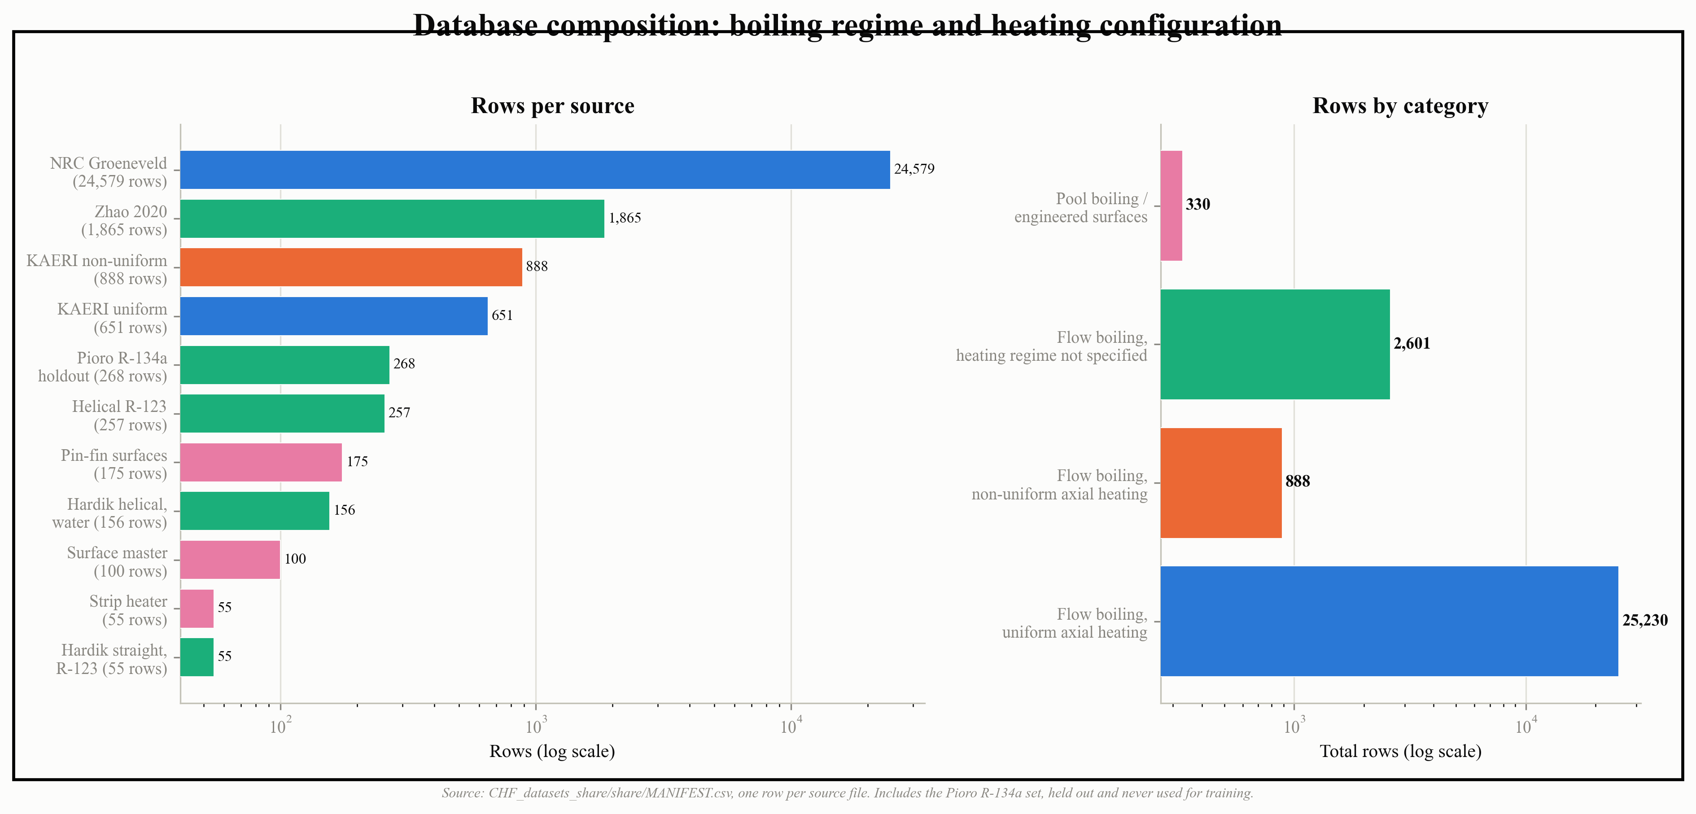
Figure 2. Database composition by boiling regime and heating configuration, one bar per source file (left) and grouped into four categories (right). Both axes are log scaled because row counts span nearly three orders of magnitude, from 55 to 24,579.
This imbalance matters for how the results in Section 3 should be read. Pool boiling makes up only about 1 percent of the merged database by row count, which is part of why Section 3.3's inference procedure declines to produce a prediction for zero mass flux rather than trusting the pooled correction to have learned pool boiling well from so little data. Non-uniform axial heating is similarly a minority case, a single 888-row dataset next to 25,230 rows of uniform heating, so any result reported for the KAERI non-uniform set later in this paper, including in Table 4, is a result on this project's only non-uniform-heating source, not an average over several. Figure 3 shows directly what that non-uniform condition looks like in practice: local quality plotted along the heated length for a sample of individual tests from the KAERI non-uniform set, each tracing out its own axial profile rather than the single monotonic curve a uniformly heated tube would produce.

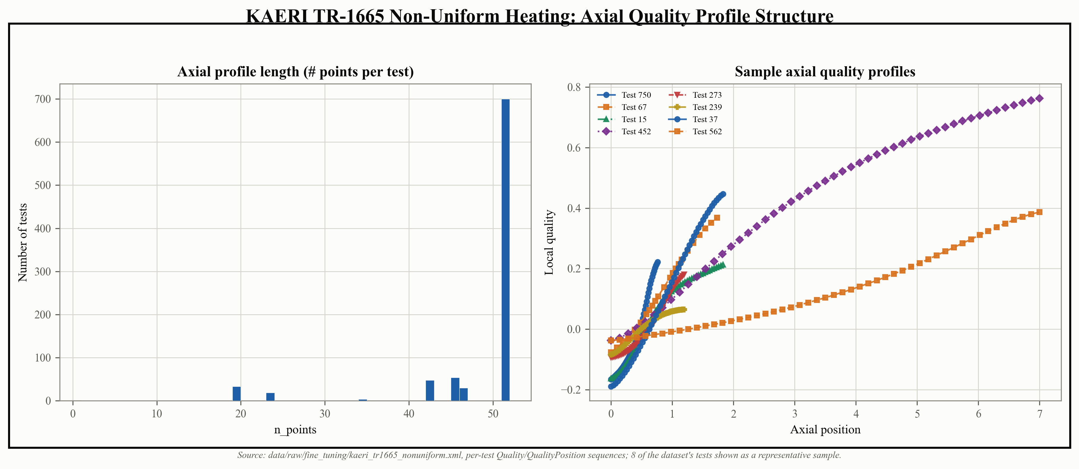
Figure 3. Axial quality profiles for a sample of individual tests in the KAERI non-uniform heating dataset (left: how many axial points each test reports; right: local quality against axial position for eight sample tests), illustrating what a non-uniform axial heat flux profile actually looks like at the level of a single test.

3. Machine-Learning Methodology
Figure 4 maps the rest of this section before the detail begins: raw sources of the kind just described in Section 2 are merged and preprocessed (Section 3.1), passed through the physics-plus-learned-correction hierarchy (Section 3.3), evaluated under four validation strategies (Section 3.4), and turned into a final prediction carrying its own calibrated uncertainty interval.
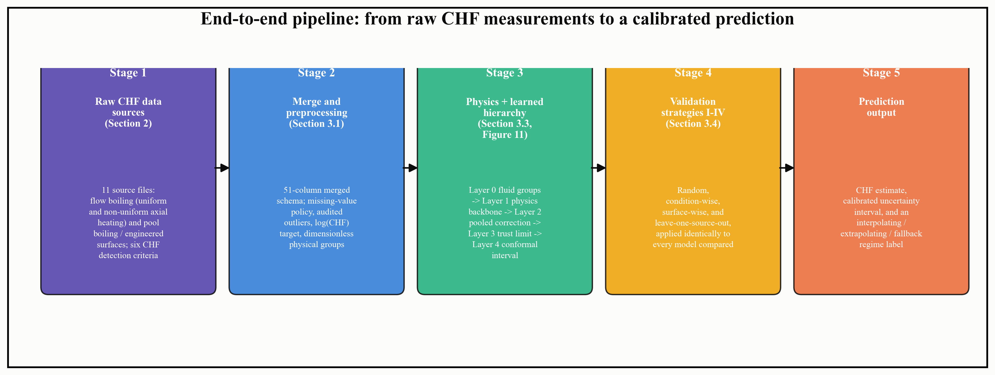
Figure 4. End-to-end pipeline from raw CHF measurements to a calibrated prediction, naming the section that describes each stage in detail.

3.1 Data Preprocessing
Merging independent CHF datasets into a single modeling table, described in Section 2, does not by itself produce something a model can be trained on safely. The merged schema used in this project carries 51 columns once every source's fields are combined, and getting from that raw merge to a trustworthy training set involved five distinct kinds of preprocessing work: deciding what to do about missing values, deciding which unusual points were real and which were errors, choosing how to scale the inputs and the target, checking which features actually carried independent information, and working out what the effective dimensionality of the problem really was.
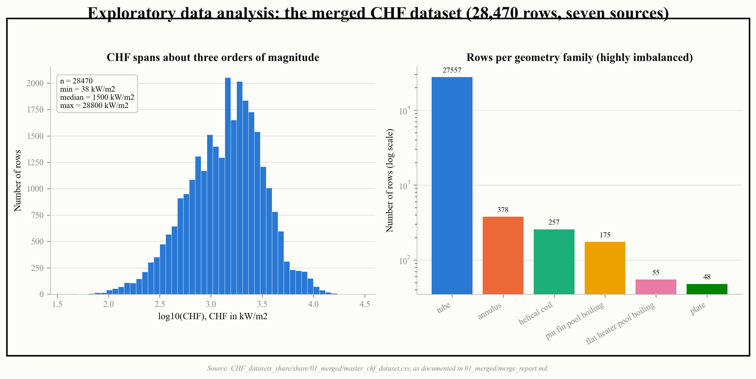
Figure 5. Exploratory data analysis on the real merged dataset (28,470 rows): the CHF distribution spans about three orders of magnitude (left), and row counts per geometry family are highly imbalanced, from 27,557 tube rows down to 48 plate rows (right, log scale).

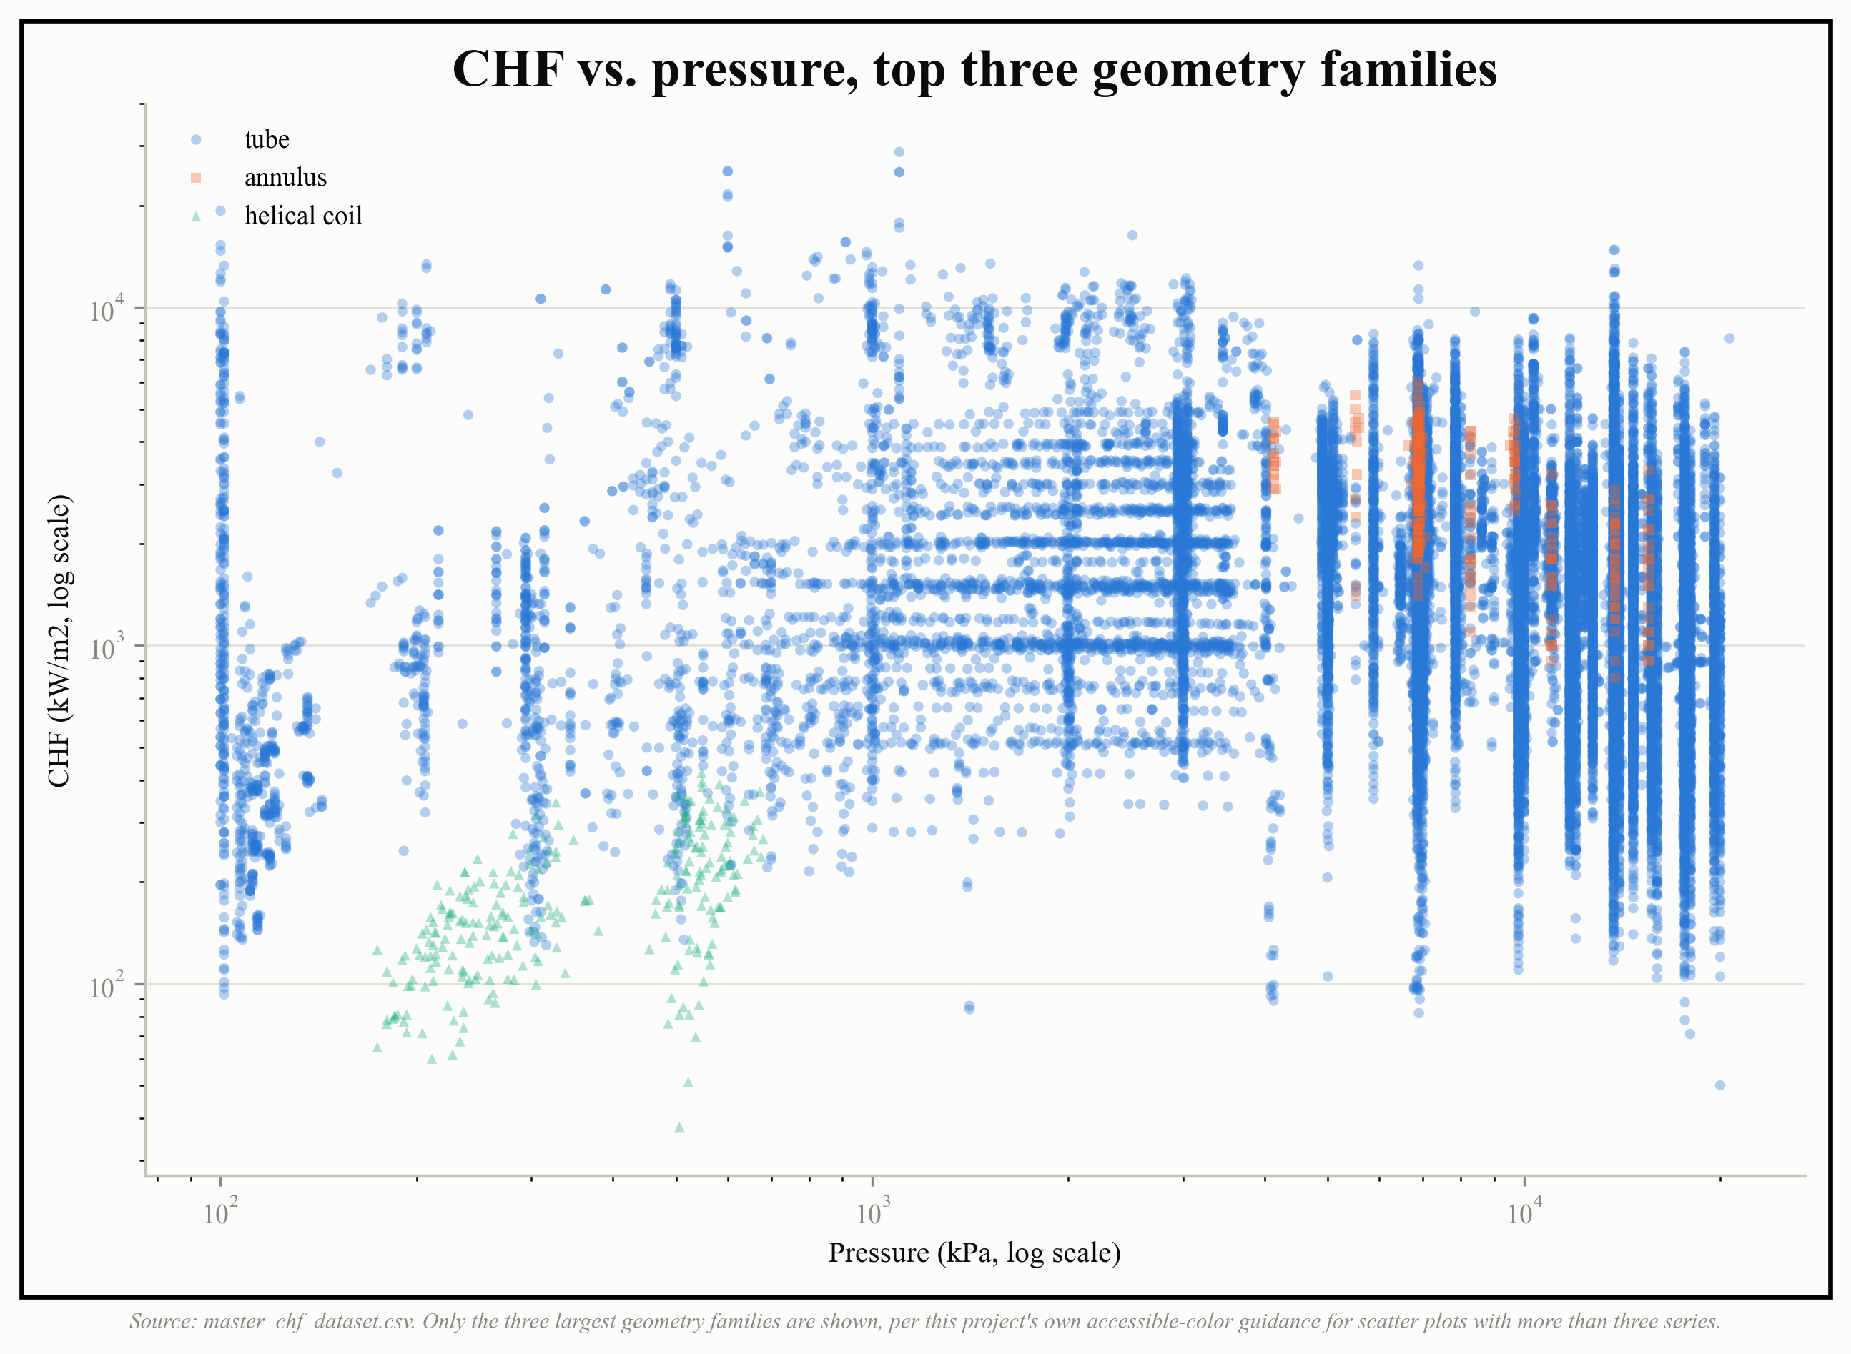
Figure 6. CHF against pressure for the three largest geometry families in the merged dataset. Only three series are shown because more than three categorical colors on a scatter plot stop being reliably distinguishable, including under color-vision deficiency.
Missing-value treatment. Column coverage across the merged dataset is extremely uneven. Core flow variables such as CHF itself, mass flux, and geometry family are present on effectively every row, heated length, quality, and pressure are present on more than 99 percent of rows, and diameter is present on 98.3 percent, but surface-specific columns such as roughness factor and surface material are present on well under 1 percent of rows, simply because the great majority of sources never measured them. The rule adopted throughout this project is to never impute a value a source does not report, rather than filling a gap with a column mean, a model-based estimate, or any other guess. This matters because two different kinds of missingness are easy to confuse: a pool-boiling dataset has no mass flux or quality because there is no forced flow to measure, which is a physically meaningful absence, not missing data in the usual sense, while a flow-boiling paper that simply never reported subcooling is missing data that does, in principle, exist. Only the second kind is a candidate for careful imputation at all, and even there this project chose to leave the gap as a genuine missing value rather than invent a number, so that no model result can be quietly resting on an assumption dressed up as a measurement.
Outlier detection. The instruction not to remove outliers blindly is worth taking seriously, because this dataset contains at least three genuinely different situations that a single statistical outlier rule would treat identically and should not. First, CHF itself spans three orders of magnitude, from about 15 to over 44,000 kW per square meter, so a small number of very high or very low values are real physical outcomes at extreme pressure, mass flux, or subcooling combinations, not errors, and a naive standard-deviation filter would delete exactly the high-CHF conditions that matter most for margin calculations. Second, some points are genuinely suspect due to how they were collected rather than what they measure: one dataset used in this project was digitized by eye from a published scatter plot, which carries an estimated 5 to 10 percent error on both axes, and this project's response was not to delete those points but to keep them clearly labeled as a lower-trust source used only for out-of-distribution testing, never for training. Third, some apparent outliers are unresolved disagreements in the literature itself: one pool-boiling study's own published text gives CHF values for its coated surfaces that do not match the range quoted for the same study in a later review paper, and rather than guessing which source was right, the values were kept exactly as printed in the original paper and the discrepancy was documented rather than silently resolved. A fourth case is not an outlier at all but a data-entry defect masquerading as one: a diameter column that had silently defaulted to a fixed placeholder value whenever the true diameter was missing was only caught because the affected dataset was the pipeline's worst performer, and the fix there was to correct the underlying value, not to remove the rows.
Normalization and standardization. Because CHF spans three orders of magnitude, every model in this project is trained on the logarithm of CHF rather than the raw value, with predictions exponentiated back before any accuracy metric is computed. For the input side, an early baseline simply standardized the raw physical variables to zero mean and unit variance before fitting, which is a reasonable default but treats pressure, mass flux, and fluid identity as arbitrary numbers to be rescaled rather than physical quantities with known relationships to each other. The approach carried into the final pipeline instead collapses the fluid and flow variables into a small set of dimensionless physical groups, an inverse Weber number, a density ratio, a length-to-diameter ratio, a subcooling ratio, and a reduced pressure, so that water at 15 megapascals and a refrigerant at 1 megapascal that are in physically equivalent states map to the same point in the input space. This is not just a scaling convenience: tested directly, moving from raw standardized inputs to this dimensionless formulation improved cross-fluid prediction error by a factor of roughly 10 to 32, while leaving within-fluid accuracy essentially unchanged, 0.851 against 0.849 R-squared, which is the control that shows the gain is coming from better cross-fluid normalization and not from some unrelated side effect.
Feature correlation analysis. Run naively on data pooled from many independent laboratories, a feature correlation analysis in this project turned out to be actively misleading rather than simply noisy. Computed across pooled engineered-surface data, the correlation between surface roughness and CHF came out negative, but computed within each individual study it came out positive, matching the physical mechanism the source papers themselves describe. Extending the same kind of analysis to ask how much variance a purely administrative variable, which laboratory produced a given row, explains on its own, rather than only checking physical features against the target, is what first revealed that source identity alone can account for the majority of the apparent signal in a small dataset. Correlation analysis was also used directly as a leakage-detection tool rather than only a feature-selection one: several columns in the merged data, including one combination of electrical power, perimeter, and flow area in one dataset, and a heater-power column in another, reconstructed the CHF target almost exactly through simple algebra once checked, and were excluded once that reconstruction was confirmed. In this project, feature correlation analysis removed at least as much as it selected.

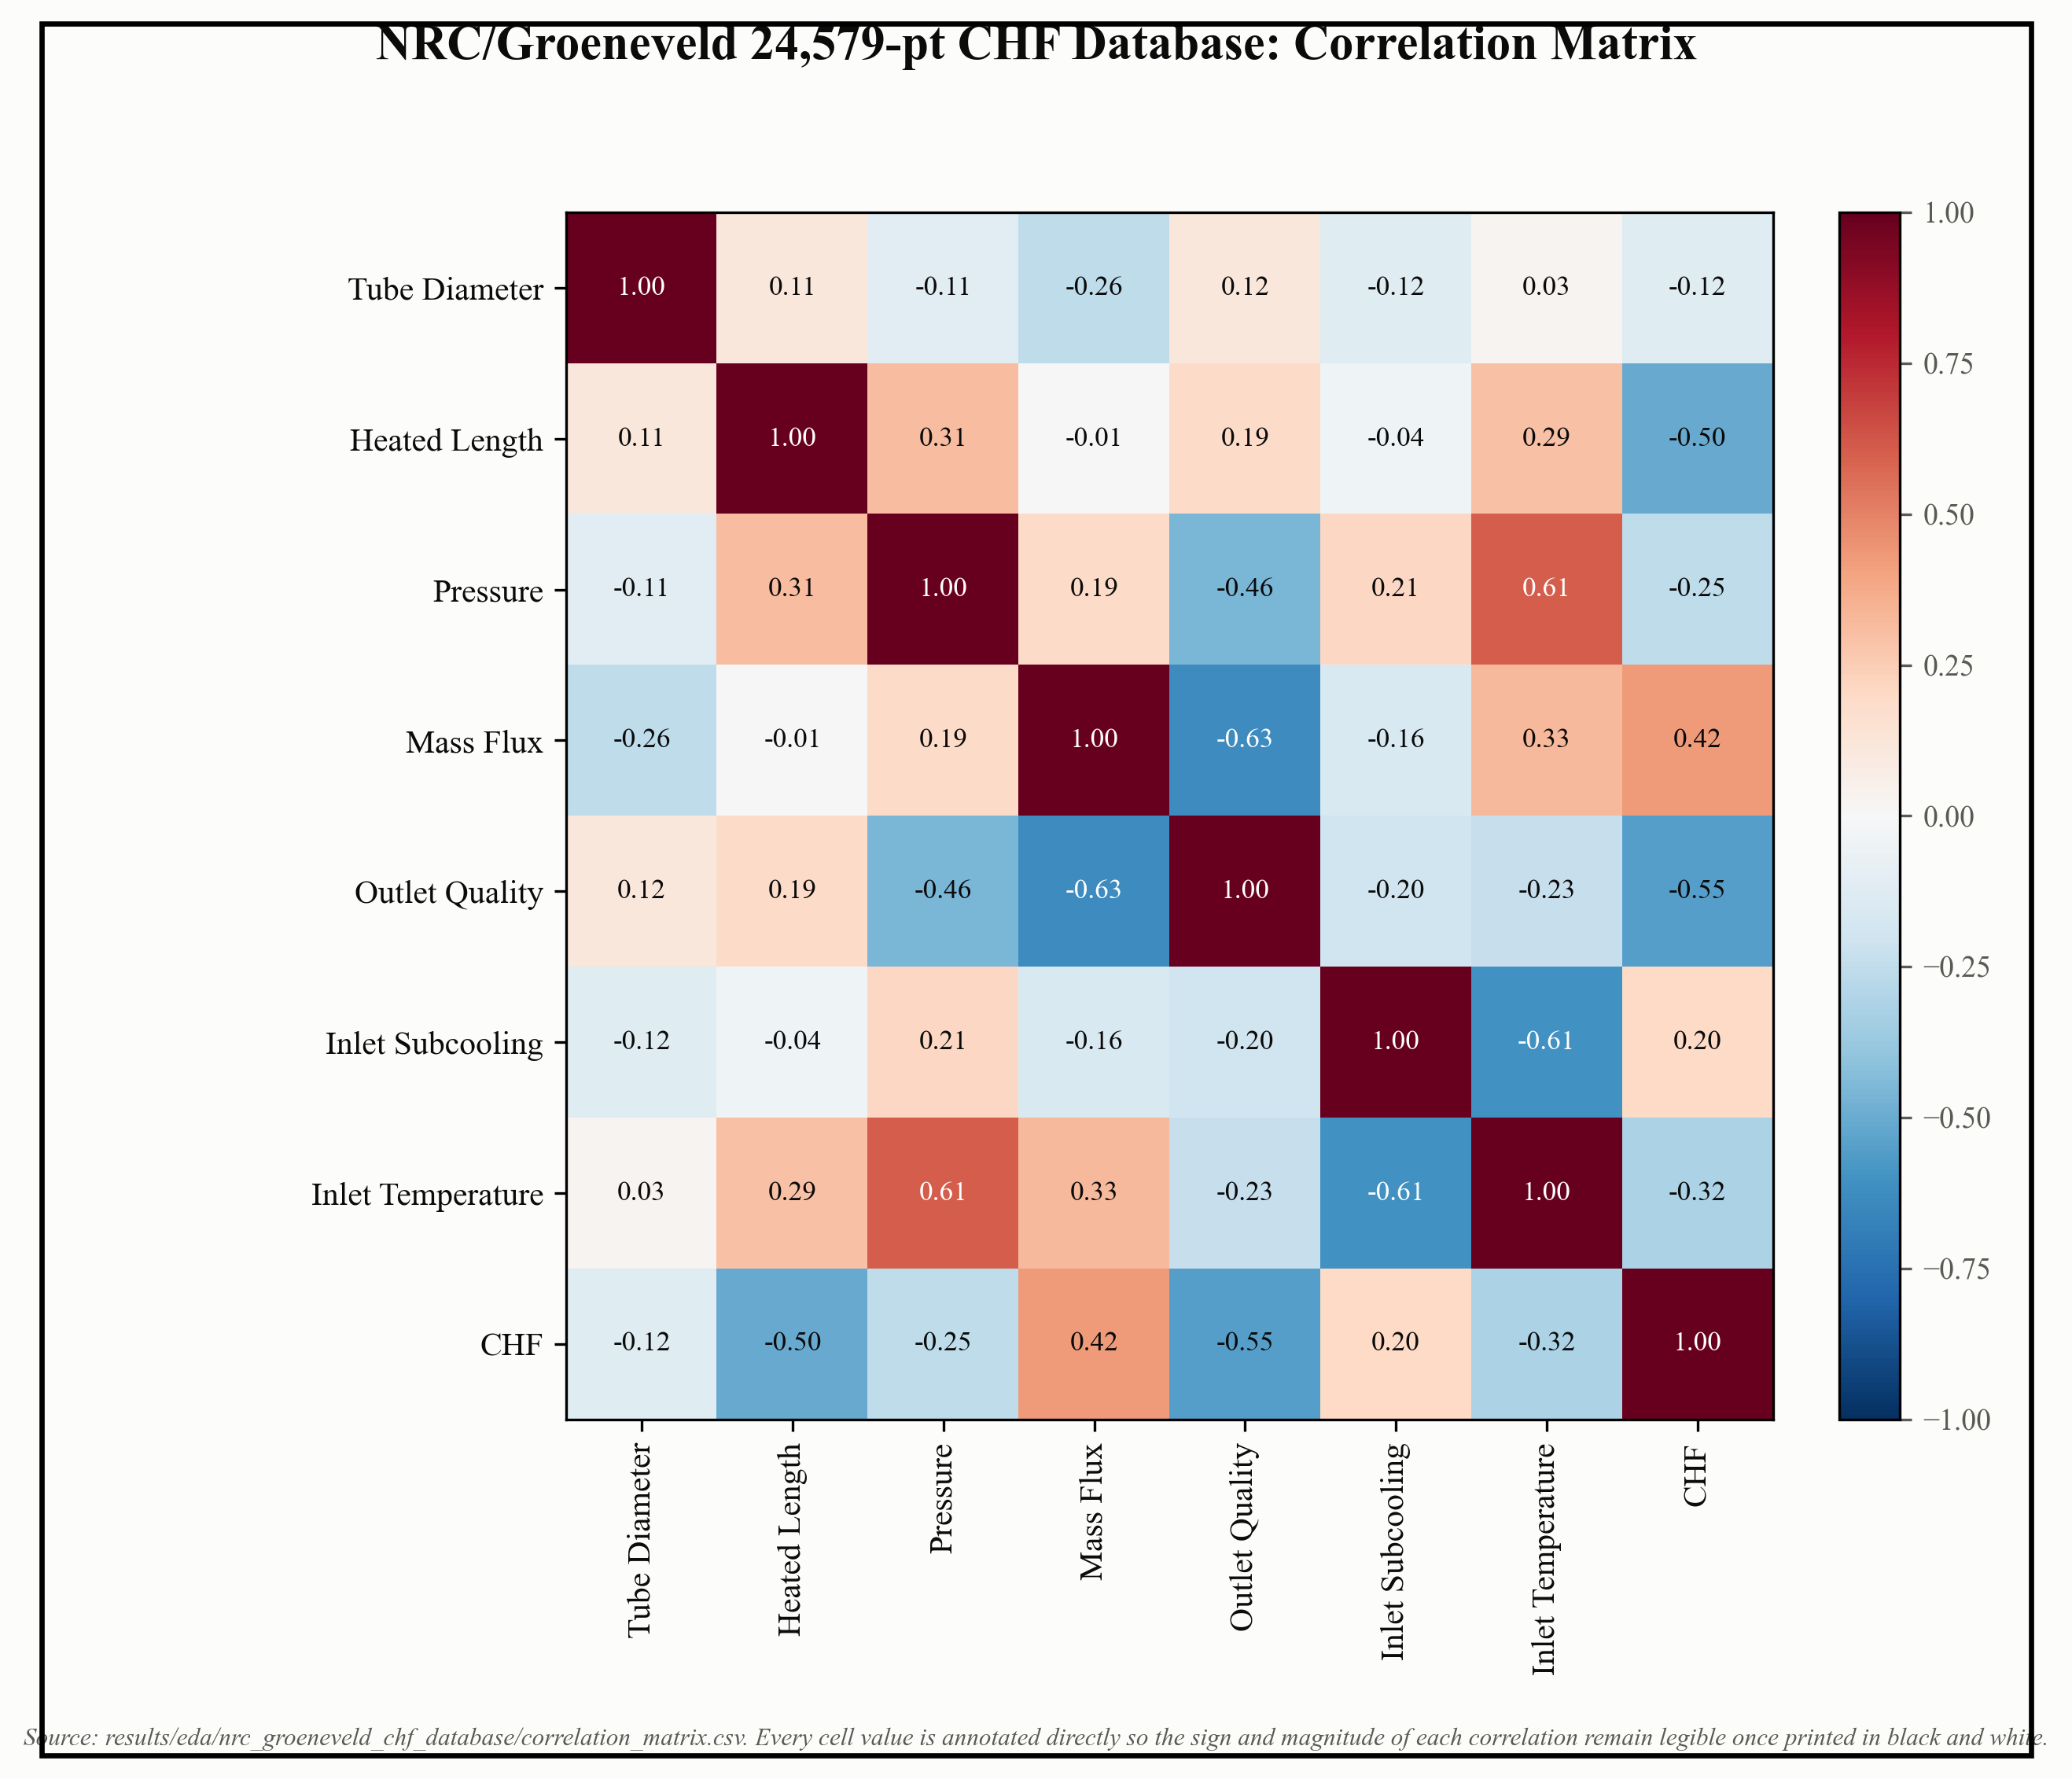
Figure 7. Pairwise correlation matrix for the NRC/Groeneveld sub-dataset (24,579 rows, this project's single largest source), the kind of within-source correlation check described above. Mass flux and outlet quality show the strongest linear association with CHF here (0.42 and -0.55); note that this is one source's own internal correlation structure, not the pooled, cross-source analysis whose sign-reversal problem is discussed in the same paragraph.
Dimensionality analysis. The physical problem itself is low-dimensional: CHF in flow boiling is conventionally described by four or five variables, pressure, mass flux, quality, diameter, and heated length, plus fluid identity, so this project never faced the classic high-dimensional setting that would call for something like principal component analysis. The dimensionality problem that did show up came from merging, not from the physics: once seven independent sources were combined, the resulting schema carried 51 columns, because each source contributed its own geometry- or surface-specific descriptors, and the great majority of those columns are populated on well under 10 percent of rows. The practical dimensionality question in this project was therefore not how to compress a rich feature space, but how to decide, column by column, which of these sparsely populated fields could be used at all without either discarding most of the dataset by requiring every column to be present, or inventing values for rows that never measured that quantity in the first place. The dimensionless feature construction described above served this purpose as well, replacing a long, sparse tail of source-specific raw columns with a small, fixed set of variables that apply to every row regardless of which source it came from.
None of these five preprocessing decisions were free of consequence, and it is worth restating the finding from Section 1.8 in this context: on one of the hardest test splits used in this project, correcting a handful of data-preprocessing issues, unit errors and a poorly populated column, with no change to the model or to any physics assumption, moved that split's accuracy from an R-squared of 0.173 to 0.711. In this project, the preprocessing choices described above turned out to matter at least as much as which model was ultimately trained on the result.

3.2 ML Models
The outline for this paper asks for a comparison of at least five algorithms. This project ended up testing considerably more than five, across several distinct phases of experimentation, and it is more honest to describe the five headline models below alongside a summary of everything else that was tried and set aside, rather than presenting only a tidy five-way comparison as if it were the whole story.
Model 1, Artificial Neural Network (ANN / MLP), later joined by a Transformer encoder variant. Table 1 summarizes this project's earliest phase, the 2006 Groeneveld look-up table alone, across three splits of increasing difficulty (Split A: random; Split B: interior pressure holdout; Split C: edge-of-range extrapolation; Section 3.4), and already showed the pattern the rest of this paper returns to: strong accuracy under an easy split, sharp decline under a hard one.
Model 2, Random Forest. A random forest builds a large number of decision trees on randomly resampled subsets of the data and features, then averages their predictions, which the outline correctly identifies as useful for capturing nonlinear relationships, ranking feature importance, and providing a fairly robust baseline that rarely fails outright. This project's own testing on the seven-source, 28,470-row merged dataset confirmed the first two points and complicated the third: random forest was consistently strong under easier splits but degraded considerably faster than gradient boosting once the test conditions became genuinely unseen.
Table 1. Early baseline comparison on the 2006 Groeneveld look-up table (11,088 usable rows), before any real experimental data was introduced. MAPE is mean absolute percentage error, computed on Split C.
Model | Split A (R2) | Split B (R2) | Split C (R2) | MAPE on Split C
Grid interpolation (physical baseline) | N/A | 0.999 | 0.841 | 20.8%
Degree-2 log ridge regression | 0.847 | 0.871 | 0.755 | 35.8%
Neural network, ANN (log target) | 0.991 | 0.989 | 0.628 +/- 0.072 | 40.0%
Tree ensembles (Random Forest, gradient boosting variants) | 0.999 | 0.988 | about 0.43 | about 42%
Pressure-gated blend (raw target) | 0.999 | 0.999 | 0.466 +/- 0.228 | 67.1%

Deterministic grid interpolation held up far better than any learned model under genuine extrapolation here, the first sign that a physical anchor can matter more than model choice, a lead this paper follows through to the proposed hybrid below. (An initially reported 0.855 blend result did not replicate under multi-seed verification and was withdrawn; every number in this paper is a multi-seed mean, never a single run.)
Model 3, Gradient Boosting. Gradient boosting builds trees sequentially, with each new tree correcting the errors left by the ones before it, and the outline specifically names XGBoost as a strong candidate for structured, tabular experimental data such as this project's own. The implementation actually trained and evaluated in this project's own bake-off was a histogram-based gradient boosting model rather than the XGBoost package specifically, and it is worth being precise about that distinction rather than blurring the two together. Section 1.5 already reviews XGBoost results from the wider published literature, where it reaches an R-squared above 0.94 on rod-bundle CHF data, close behind a Transformer architecture's 0.956. Within this project's own testing, the gradient boosting model it did train turned out to be the strongest or joint-strongest performer of every model compared, under every one of the four validation strategies used, as Table 2 shows.
Table 2. Model comparison across four validation strategies, evaluated on the same seven-source, 28,470-row merged dataset (includes pin-fin and helical-coil pool-boiling surfaces). Strategies are defined in Section 3.4.
Model | Strategy 1: Random (R2) | Strategy 2: Condition-wise (R2) | Strategy 3: Surface-wise (R2) | Strategy 4: Leave-one-source-out (R2)
Gradient boosting (histogram-based) | 0.968 | 0.890 | 0.173 | 0.784
Random Forest | 0.965 | 0.875 | 0.219 | 0.269
Neural network (ANN) | 0.921 | 0.515 | -4132.9 | -5.150
Gaussian Process Regression | 0.872 | -0.051 | -0.813 | 0.539
Physics-informed neural network (PINN) | 0.876 | -64.9 | -3906.9 | -6.022

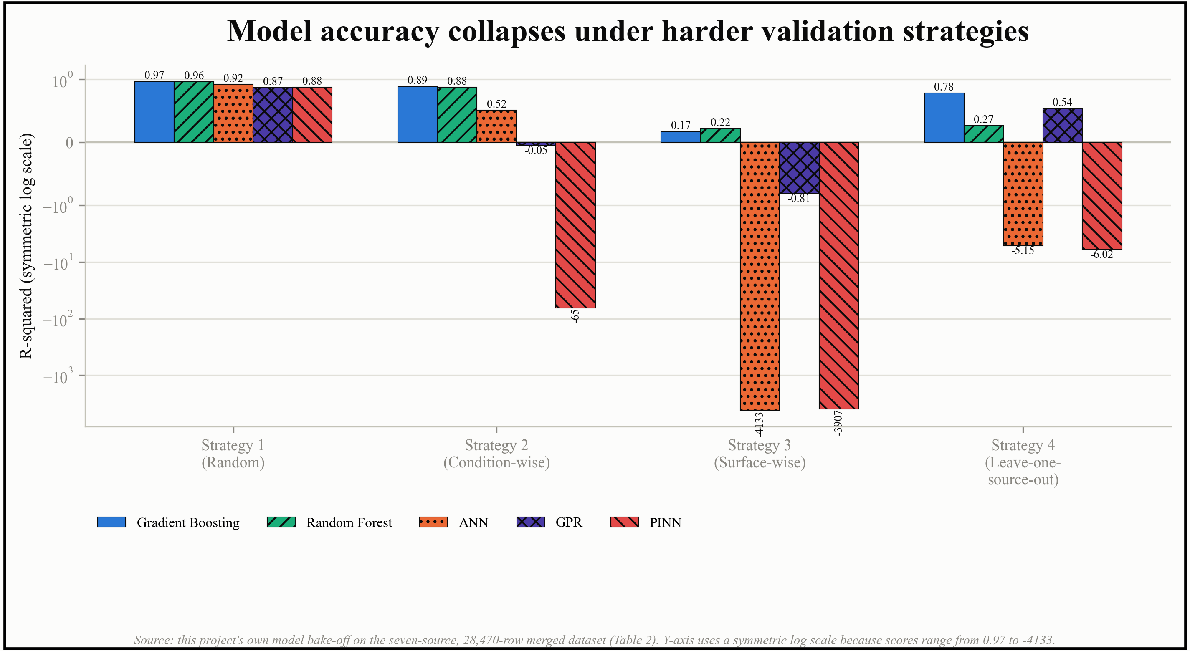
Figure 8. Table 2 shown visually. The y-axis uses a symmetric log scale because scores range from 0.97 to -4133; a linear axis would make every bar except PINN's look identical.
The physics-informed neural network in Table 2 deserves a brief, honest note, since this project spent considerable effort on it before setting it aside. Early results looked promising when the target was reparametrized as a residual correction, reaching an R-squared of 0.847 against a deterministic baseline of 0.841. On closer inspection, however, the monotonicity penalty that was supposed to enforce physical behavior read exactly zero throughout training, meaning it was never actually active, and the best-performing configuration had a fitted weight of zero on both of its physics penalty terms. In other words, the apparent gain came from how the target was framed, not from any physics constraint actually doing work, and Table 2 shows the same model collapsing to an R-squared of minus 64.9 and minus 3900 under harder splits. Combined with the fact that CHF has no governing partial differential equation for a physics-informed network to enforce in the first place, this project moved away from the physics-informed neural network as a standalone architecture and toward the residual-correction-on-a-correlation approach described under Model 5 below, which keeps the physical anchor but does not depend on an unstable penalty term.
Model 4, physics correlation baseline (zero fitted parameters). Alongside the four learned models above, this project also carried a purely physical model through every comparison: an empirical CHF correlation, such as Katto and Ohno's, the Biasi correlation, or the 2006 Groeneveld look-up table itself, chosen automatically for whichever training subset was being evaluated, with no fitted parameters of its own. In a later, more tightly scoped phase of this project, restricted specifically to flow boiling and using a different, eight-source, 28,582-row dataset than Table 2, this physics-only baseline was compared against several learned models under the same four validation strategies, shown in Table 3.
Table 3. Physics-only baseline versus five increasingly structured learned variants, flow-boiling-only dataset (eight sources, 28,582 rows), same four validation strategies as Table 2.
Model | Strategy 1: Random (R2) | Strategy 2: Condition-wise (R2) | Strategy 3: Surface-wise (R2) | Strategy 4: Leave-one-source-out (R2)
Physics only (Katto-Ohno), no learning | 0.779 | 0.508 | 0.505 | 0.785
No physics, raw features (data-driven only) | 0.979 | 0.903 | -17.997 | 0.719
latent-heat baseline as an added feature | 0.970 | 0.877 | 0.711 | 0.800
Katto-Ohno baseline as an added feature | 0.978 | 0.812 | 0.606 | -0.797
Dimensionless features (Section 3.1) | 0.982 | 0.790 | 0.252 | -0.467
bounded, monotone correction with trust | 0.957 | 0.854 | 0.506 | 0.710

The pattern is the same one seen throughout this paper: every purely or mostly data-driven variant wins comfortably when the split is easy and can collapse badly when it is not, most sharply the raw, unstructured data-driven model, which drops to an R-squared of minus 18 under a surface-wise split, while the physics-only baseline never scores as high but never collapses either, staying within a narrow band of 0.5 to 0.79 across every split tested. Adding physically motivated structure one piece at a time did not fix this monotonically. A latent-heat baseline recovered most of the surface-wise collapse, from minus 18 to 0.711, but adding the Katto-Ohno correlation and then dimensionless features on top of it made the leave-one-source-out score worse, not better, turning a positive 0.719 into a negative 0.797 and then a negative 0.467, before the final bounded, monotone correction brought leave-one-source-out back up to 0.710. The lesson carried into Section 3.3 is specific: adding physical structure can help or hurt depending on exactly how it is added and which split is being tested, which is why the proposed hierarchy bounds the learned correction explicitly with a trust term rather than assuming any one physics-guided variant is safe by default.
Model 5, Proposed hybrid architecture. Rather than choosing between a data-driven model and a physics correlation, the model proposed in this paper combines both, using the physics correlation as a floor and a learned model only to correct it. The full hierarchy is described in Section 3.3. Evaluated on the same entirely unseen datasets used to test generalization elsewhere in this paper, this hybrid consistently outperformed both of its own ingredients taken alone, as Table 4 shows.
Table 4. Performance on entirely unseen datasets: physics alone, a purely data-driven model with no physics, and the proposed hybrid pipeline, evaluated dataset by dataset (flow-boiling-only data, eight sources).
Unseen dataset | Physics alone (R2) | ML, no physics (R2) | Proposed hybrid (R2) | Within +/-10%
KAERI non-uniform | 0.797 | 0.841 | 0.970 | 47.5%
NRC | 0.926 | 0.242 | 0.944 | 47.0%
Hardik straight tube | 0.636 | -868.6 | 0.793 | 33.8%
KAERI uniform | 0.620 | 0.852 | 0.735 | 58.9%
Hardik helical coil | -0.161 | -1.214 | 0.687 | 29.7%
Helical R-123 | 0.051 | -307.7 | 0.449 | 14.8%
Pioro R-134a | -0.097 | -423.6 | -0.065 | 16.0%
Zhao 2020 | -0.437 | -1.433 | -0.429 | 7.7%
Median across all eight | +0.336 | -1.323 | +0.711 | 31.8%

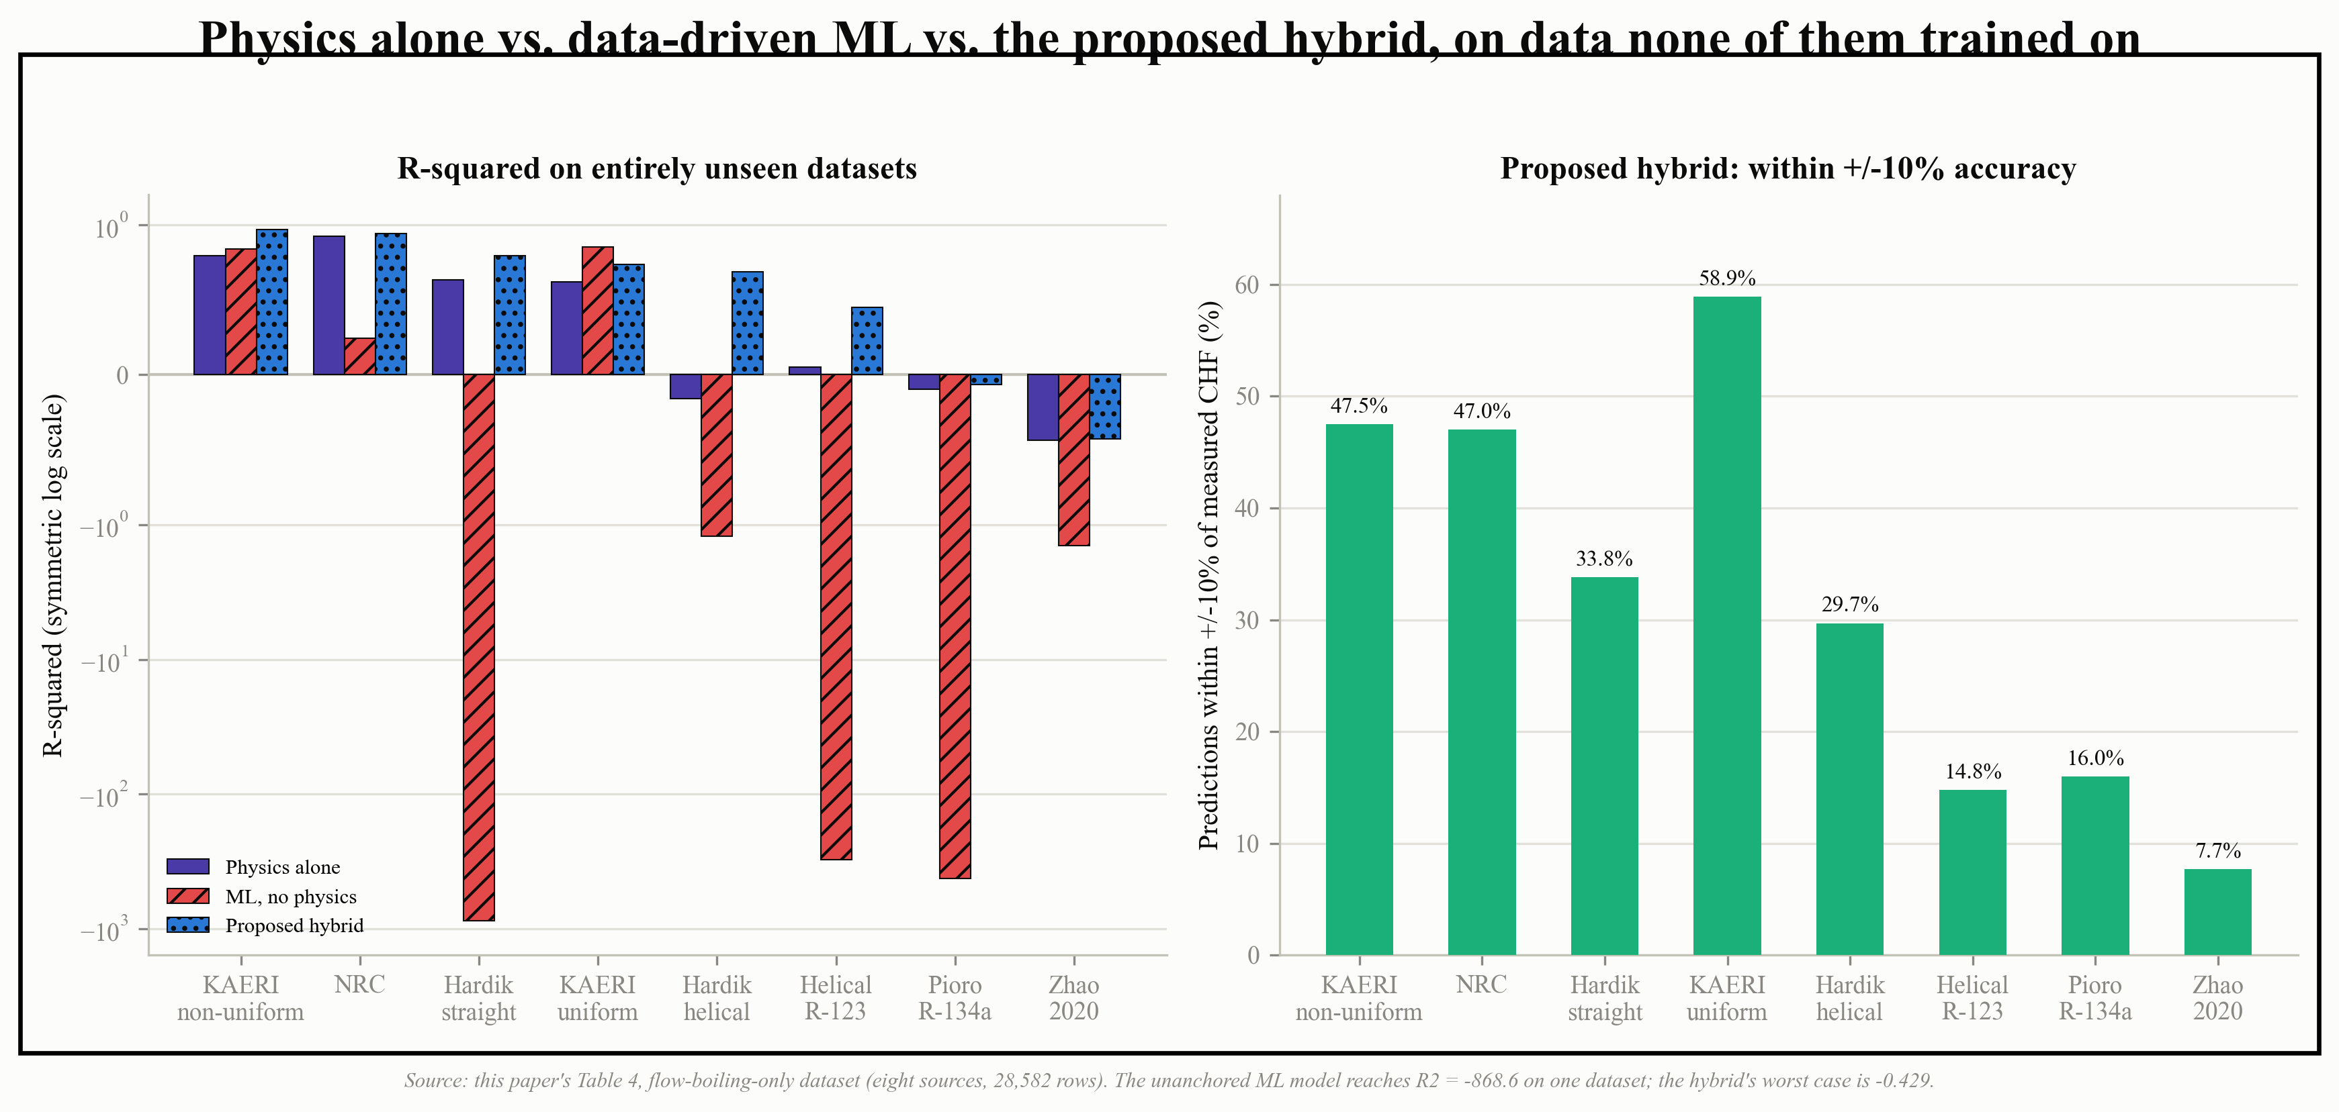
Figure 9. Table 4 shown visually: R-squared by dataset (left, symmetric log scale) and the proposed hybrid's within +/-10% accuracy by dataset (right).
The headline result in Table 4 is not the median score by itself, it is the absence of catastrophe. An unanchored data-driven model reaches an R-squared of minus 868 on one unseen dataset, a result with no practical meaning beyond signaling total failure, while the proposed hybrid's worst case across all eight unseen datasets is minus 0.429. A model that is occasionally mediocre but never that catastrophic is a fundamentally different, and for a safety-relevant quantity like CHF, considerably more useful thing than a model that is usually excellent but occasionally worthless.
Putting Table 2 and Table 4 side by side, rather than reading each in isolation, surfaces a pattern neither table shows clearly on its own: the model or approach that wins is not always the one that wins everywhere else. Gradient boosting is the strongest model under three of the four validation strategies in Table 2, but under Strategy 3 specifically, the surface-wise split that withholds pin-fin pool-boiling and helical-coil rows entirely, Random Forest edges it out, 0.219 against 0.173, a real if modest reversal at the one strategy built specifically to test an unseen surface type. A similar reversal shows up in Table 4: the proposed hybrid wins on seven of the eight entirely unseen datasets, but on KAERI uniform specifically, the plain data-driven model with no physics scores higher, 0.852 against the hybrid's 0.735, even though the same plain data-driven model is far behind the hybrid on every other dataset in the table, including the non-uniform-heating KAERI set right next to it. Figure 10 makes both reversals visible at once.
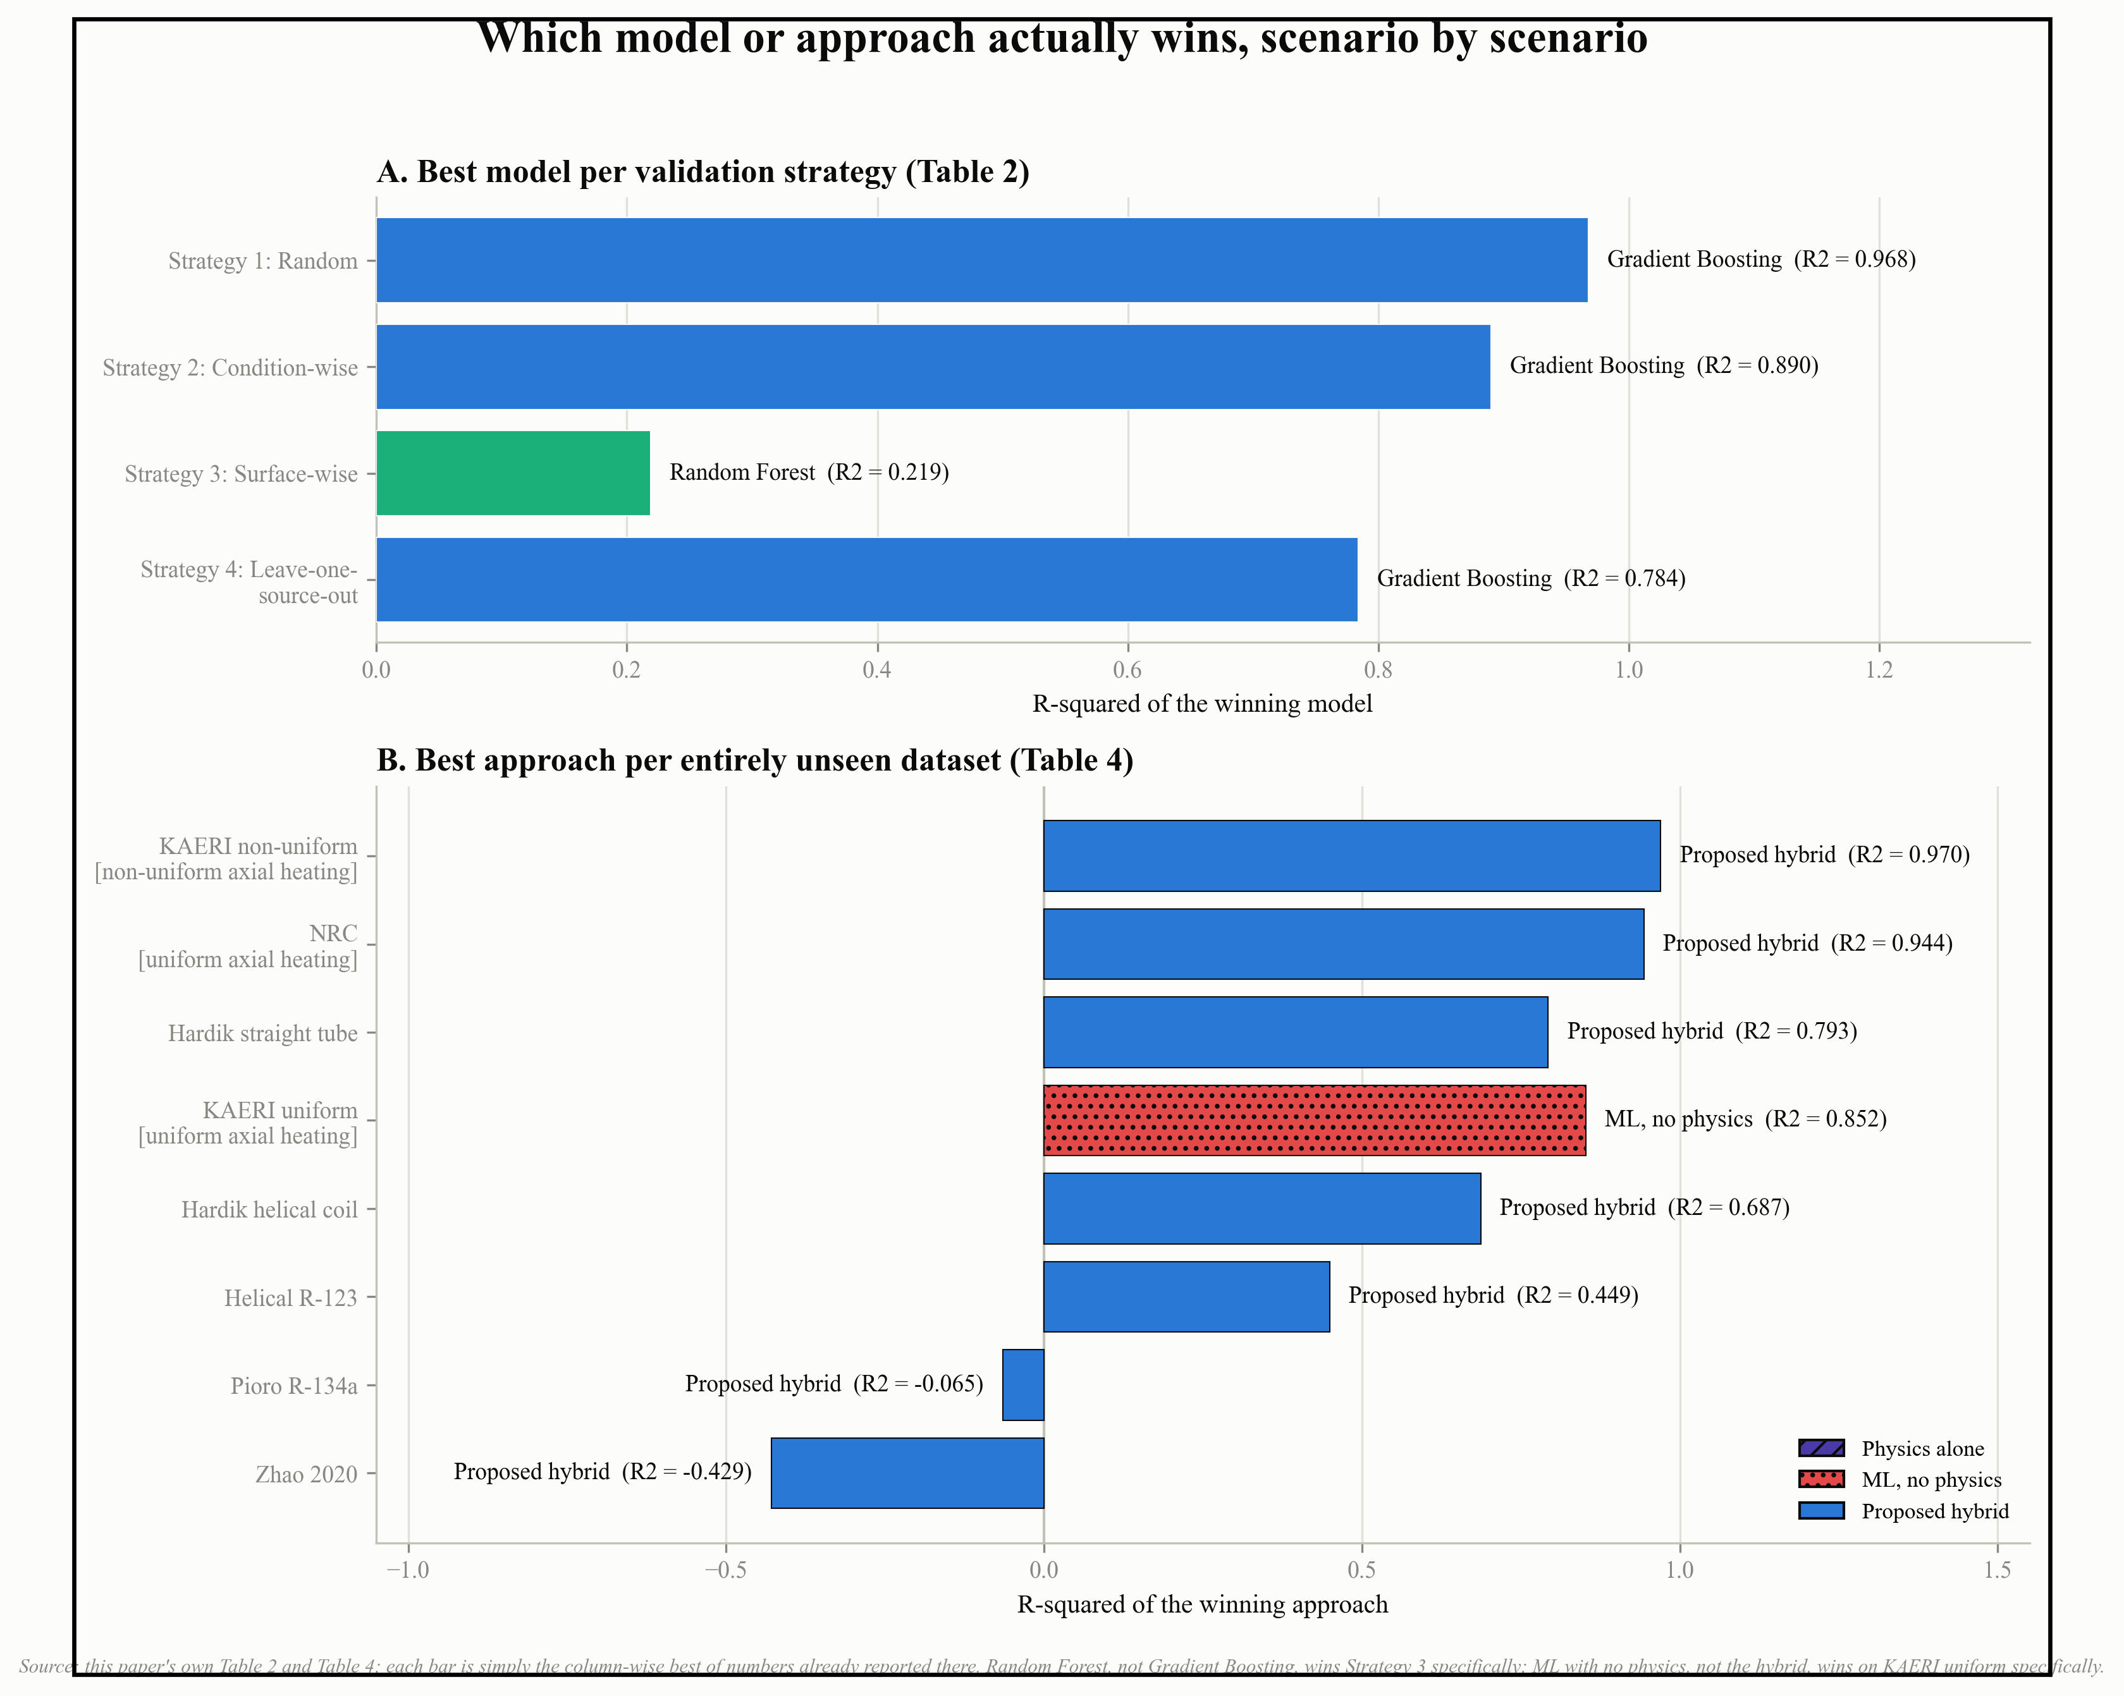
Figure 10. Which model or approach actually wins, scenario by scenario, read directly off Table 2 (top) and Table 4 (bottom). Bracketed labels flag the two directly comparable heating configurations, KAERI uniform and KAERI non-uniform, so that a single dataset pair matched on almost everything except axial heating profile can be compared directly.
Other models and configurations explored. The five models above are the headline comparison; Table 5 briefly records the other ideas tried and set aside, negative results included, since they are still useful evidence about what does not work for this problem.

Table 5. Additional models, hyperparameter variations, and architectural ideas tested over the course of this project, beyond the five headline models above.
Technique tried | What it was meant to test | Outcome
Linear / Ridge regression | A simple baseline, expected to be outperformed | In one leave-one-publication-out test, plain linear regression beat gradient boosting, XGBoost, and Gaussian process regression; kept as a standing baseline
k-Nearest Neighbors (k=3, distance-weighted) | A grid-memorization diagnostic, not a serious final model | Useful for showing how much of a dataset's apparent accuracy comes from simply having a close neighbor nearby
Degree-2 / degree-4 polynomial ridge | A simple nonlinear baseline on standardized inputs | Reasonable inside the training range, error grows sharply outside it once expanded to higher-degree terms
Stacked ensemble of multiple model types | Whether combining models improves robustness | Scored an R-squared of 0.459 against 0.945 for a single tree model under honest, source-grouped evaluation; the ensemble's own weights overfit to the training sources
Physics-informed neural network (PINN) | Whether enforcing physical penalties during training improves generalization | Apparent gains traced to target reparameterization, not the physics penalty, which was inactive; catastrophic instability under distribution shift (see Table 2); not carried forward as a standalone model
Deep ensembles for uncertainty | Calibrated confidence intervals from ensemble spread | 95%-nominal intervals contained the true value only 9 to 22% of the time on unseen data; replaced with conformal prediction
Pretraining and fine-tuning (MLP and Transformer) | Transfer learning as a head start for real-data fine-tuning | Improved extrapolation R-squared over training from scratch, but pooling all fine-tuning domains together underperformed separate per-domain fine-tuning in 8 of 10 comparisons
LoRA (low-rank adapters) | Cheaper fine-tuning with fewer trainable parameters | Reached an R-squared of 0.685 using only 8.8% of parameters trainable, close to full fine-tuning's 0.696
Mixture-of-Experts routing | Route pool-boiling and flow-boiling inputs to specialized sub-models | The routing gate did not learn the distinction reliably; abandoned in favor of a single pooled correction (Section 3.3)
Inverse dataset-size weighting | Reduce the influence of one very large source on training | Median R-squared fell from 0.777 to 0.767; rejected
Absolute-error loss instead of squared error | Match the loss function to the reported accuracy metric | Median R-squared fell to 0.700; rejected
Correlation stacking (Biasi / LUT as extra features) | Give the model a physics correlation's output as an input | Median R-squared fell to 0.727; rejected
Missing-value indicator column | Flag rows with incomplete data explicitly | Made results worse (0.660 vs 0.727); the indicator effectively leaked fluid identity, since it fires only on non-water rows
Weber number on diameter / boiling-number target | Reformulate inputs or target in the correlation literature's native dimensionless form | Median R-squared 0.731 and 0.703 respectively; both rejected in favor of the simpler dimensionless formulation in Section 3.3
Backbone ensembling across physics correlations | Avoid betting on a single physics correlation | Helped one dataset, hurt another; no single global choice served both, so a single best-correlation rule was kept instead

The one change from this round that actually stuck was not a modeling idea at all: correcting a fabricated placeholder in one dataset's diameter column (Section 1.8) -- fixing the data mattered more, more often, than any model, loss, or architecture choice.

3.3 Proposed Model Hierarchy
The model proposed in this paper, referred to as Model 5 above, is not a single network but a hierarchy of five layers, each one added specifically because an earlier, simpler design failed in a documented way somewhere in this paper. Table 6 lists the five layers in order.
Table 6. The proposed model's layer hierarchy, from raw inputs to a final prediction with an uncertainty interval.
Layer | Component | Purpose
Layer 0 | Fluid properties and dimensionless groups | Converts fluid name and pressure into density, surface tension, and latent heat, then collapses the inputs into a small set of dimensionless numbers (inverse Weber number, density ratio, length-to-diameter ratio, subcooling ratio, reduced pressure), so the model never sees a raw fluid label
Layer 1 | Physics backbone (zero fitted parameters) | An empirical correlation such as Katto-Ohno, Biasi, or the 2006 look-up table, selected automatically by whichever has the lowest error on the training rows only; this is the floor that prevents catastrophic failure
Layer 2 | Pooled learned correction | A single tree-based model predicting the logarithm of the ratio between measured CHF and the Layer 1 backbone prediction, trained once on all sources pooled together rather than one model per dataset
Layer 3 | Trust-scaled correction limit | Scales how far the Layer 2 correction is allowed to move the Layer 1 prediction: full trust allows up to a ten-fold correction, low trust clips the correction to one and a half times, so an unfamiliar input decays gracefully back toward the physics baseline rather than the learned correction running unchecked
Layer 4 | Conformal prediction interval and regime label | Produces an uncertainty interval calibrated on a held-out calibration slice rather than on ensemble spread, and labels each prediction as interpolating, extrapolating, or falling back to the correlation alone

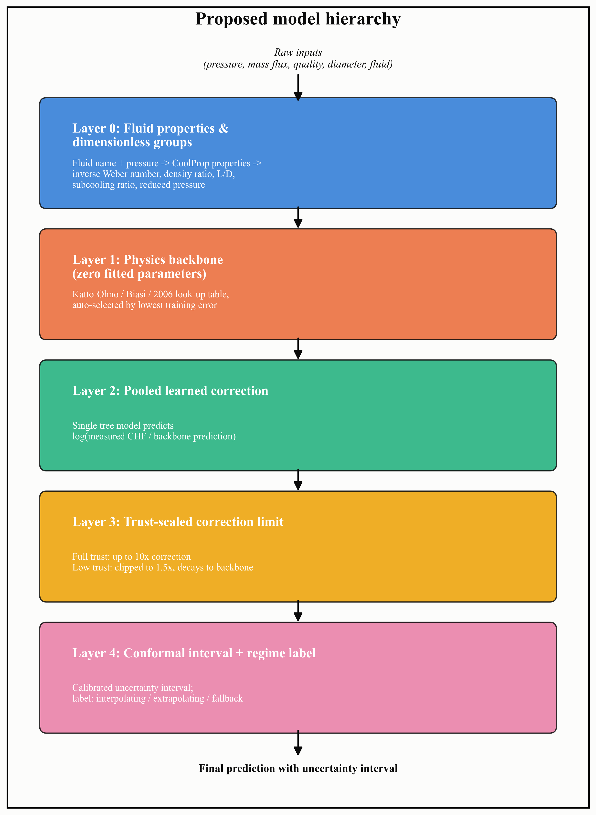
Figure 11. Table 6 shown as a schematic: raw inputs flow down through all five layers to a final prediction with a calibrated uncertainty interval.
This hierarchy exists specifically because the alternative, simpler designs tested earlier in this paper did not hold up. A router that tried to classify an input as familiar or unfamiliar and send it to either a learned model or the physics baseline was tested and rejected: even its best version reached only a median R-squared of 0.136 on entirely unseen datasets, worse than the physics baseline alone at 0.336, because the routing gate could not reliably tell an unseen fluid apart from a familiar one, the same fluid-identity blind spot discussed in Section 1.8. Layer 3 replaces that router with a dial rather than a switch: trust scales how much the correction is allowed to move the prediction, but it never chooses between two entirely different models the way a router does, so a wrong trust estimate degrades the result gradually rather than catastrophically.
Layer 2's correction is deliberately pooled across all sources rather than trained separately per dataset or routed through a mixture-of-experts gate, because both alternatives were tried first and both underperformed a single pooled model, as Table 5 already summarizes. Layer 2 can, however, be adapted efficiently to a new domain using low-rank adapters rather than full retraining, reaching an R-squared of 0.685 while updating only 8.8 percent of its parameters, against 0.696 for updating all of them, which matters in practice because it makes fine-tuning the correction on a new fluid or surface considerably cheaper without giving up much accuracy.
The inference procedure built on top of this hierarchy also encodes several of this paper's own findings as explicit refusals rather than silent extrapolation: it declines to produce a prediction for zero mass flux, since that is pool boiling and the physics backbone here is not valid there, for negative or physically impossible geometry, or for a fluid the underlying property routine does not recognize, closing off exactly the kind of silent, confident, wrong answer described as a property-lookup failure in Section 1.8.

3.4 Data Splitting Strategy
A large part of this paper is really an argument about how a CHF model should be evaluated, and that argument starts with a plain warning worth stating in the outline's own terms: do not rely only on an ordinary 80 percent training, 20 percent testing random split. If the same surface, the same laboratory, or even the same narrow condition range has rows in both the training set and the testing set, a model can score very well by learning the characteristics of that specific surface or source rather than the underlying physics of CHF, and a random split has no way of preventing this, since it does not look at where a row came from before deciding which side of the split it lands on. Every result in Table 2, Table 3, and Table 4 above exists specifically to demonstrate how large that effect actually is, and this section collects the split definitions themselves in one place.
This project used two related sets of splits at different stages. The earliest phase, working only with the 2006 look-up table, used three splits of increasing severity, summarized in Table 7.
Table 7. Split definitions used in this project's earliest phase, on the 2006 Groeneveld look-up table alone.
Split | Construction | Question it answers
Split A | Random 80/20 | Interpolation inside the grid (the optimistic case)
Split B | Interior pressure holdout | A moderately difficult, still largely interpolative case
Split C | Edge-of-range pressure extrapolation | The honest test of whether a model generalizes at all

Once real, multi-source experimental data replaced the look-up table as the main training target, this project moved to four validation strategies, matching the outline's own Strategy I through Strategy IV and used consistently for every result in Table 2 and Table 3 above.
Table 8. The four validation strategies used from Section 1.5 onward, applied consistently across every model comparison in this paper.
Strategy | Construction | Question it answers
Strategy I: Random split | Rows assigned to train or test at random, stratified by source | Interpolation; what most published CHF machine learning work actually reports
Strategy II: Condition-wise split | The highest-pressure portion of each source held out, rest used for training | Can the model handle operating conditions it has not directly seen, within a familiar source?
Strategy III: Surface-wise split | One or more entire surface types or geometries withheld completely from training | Can the model handle a surface or geometry it has never seen at all?
Strategy IV: Leave-one-source-out cross-validation | Each independent source held out in turn, with results pooled across all folds | Can the model handle an entirely new laboratory, repeated across every source in the dataset?

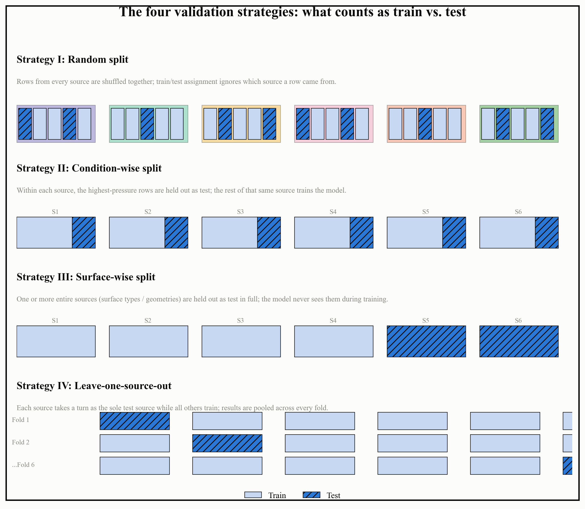
Figure 12. What train and test actually mean under each of the four validation strategies in Table 8, schematically: colored blocks are sources, dark segments are held out as test.
Two further points about how these strategies were implemented are worth recording, because both were discovered as mistakes and then fixed, and both are the kind of error that is easy to make without noticing. First, after building these splits, this project added an automatic check for degenerate groupings: a Strategy III or Strategy IV split where every group happens to contain only one row is silently identical to a random split, and a split where one group exceeds 95 percent purity from a single source is effectively Strategy IV wearing Strategy III's label. Both of these had, in fact, occurred earlier in this project and been reported as if they were the intended, harder protocol, until the automatic check caught them. Second, three grouped splits used at one point were labelled as testing generalization to an unseen laboratory when the grouping column they used actually corresponded to something else entirely, a pressure range in one case and individual coil geometries in another, both audited and renamed once discovered. Neither error changed the paper's overall conclusions, since the same pattern, strong scores on easy splits and weak or collapsing scores on hard ones, showed up consistently regardless, but both are recorded here because a validation strategy that is not actually testing what its name claims is a quiet way for an otherwise careful project to end up overstating how well a model generalizes.
The practical rule that came out of all four strategies, repeated across every model in Tables 2 through 4, is simple to state and easy to forget: a single reported R-squared value is only meaningful once the split it was measured on is stated alongside it. The same model can score above 0.9 and below minus 100 depending entirely on which of the four strategies in Table 8 was used to test it, and any CHF prediction result presented in this paper always names which strategy produced it for exactly this reason.

3.5 Performance Metrics Comparison
Every result quoted so far in this paper has led with R-squared, since that is the metric most directly comparable across the wider CHF literature. R-squared alone hides two things a reader deciding whether to trust a model actually needs: the size of a typical error in physical units, and how expensive the model was to train in the first place. This section reports both alongside R-squared, using this project's own bake-off on a random split of the merged dataset, the setting where every model looks its strongest, specifically so the comparison is not flattered by picking a harder split.
Table 9. Full metric comparison under Strategy 1 (random split): R-squared, RMSE, MAE, MAPE, and training time, on the seven-source, 28,470-row merged dataset.
Model | R2 | RMSE (kW/m2) | MAE (kW/m2) | MAPE (%) | Training time (s)
Gradient boosting (histogram-based) | 0.968 | 295.0 | 149.4 | 9.22 | 1.9
Random Forest | 0.965 | 305.0 | 143.5 | 9.36 | 8.8
Neural network (ANN) | 0.921 | 461.3 | 236.7 | 13.92 | 4.2
Gaussian Process Regression | 0.872 | 586.1 | 284.9 | 17.43 | 0.8
Physics-informed neural network (PINN) | 0.876 | 577.6 | 323.9 | 19.25 | 11.5

Two things stand out that R-squared by itself does not show. First, gradient boosting is not only the most accurate model here, it is also nearly the fastest to train, at under two seconds, second only to Gaussian process regression's 0.8 seconds, which is far less accurate. There is no accuracy-versus-cost trade-off to argue about in this comparison: the best model is also one of the cheapest. Second, the physics-informed neural network is both the slowest model to train, at 11.5 seconds, and, as Section 3.2 already discussed, one of the least reliable once the split gets harder, which is a difficult combination to justify in practice.
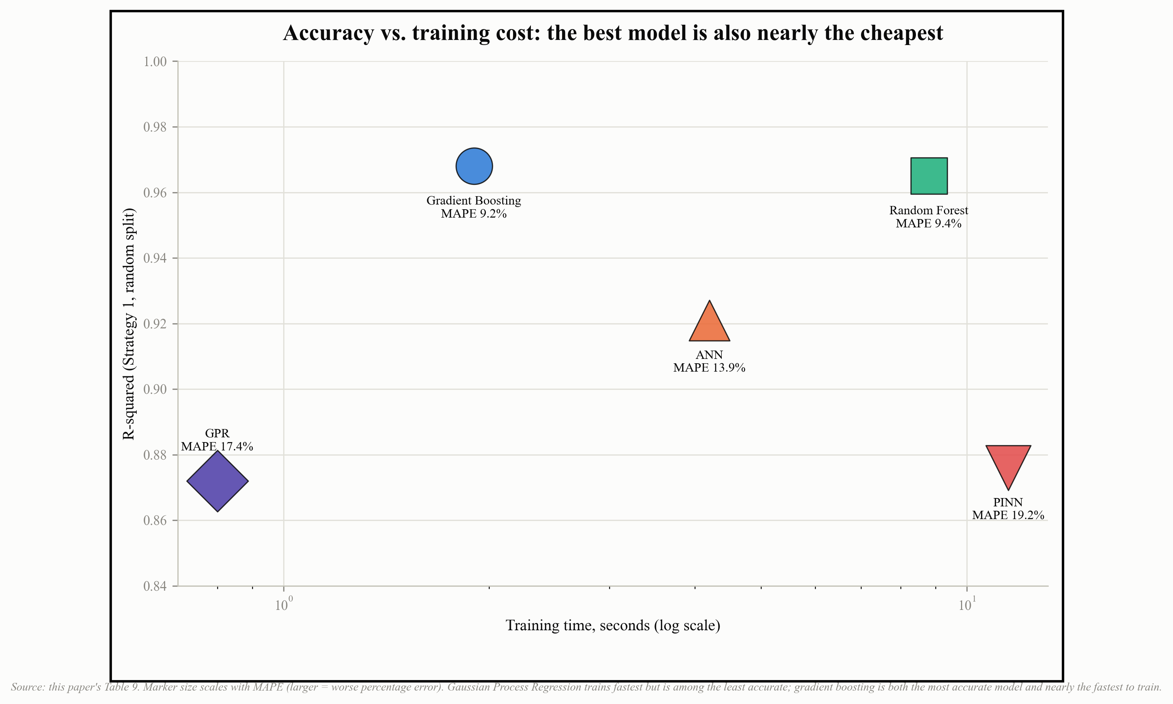
Figure 13. Table 9 as an accuracy-vs-cost view: R-squared against training time (log scale), marker size scaled to MAPE. There is no trade-off to argue about here, the most accurate model is also nearly the cheapest to train.
This project's own MLP and Transformer architectures were evaluated the same way, on the separate NRC-derived interpolation and extrapolation splits described in Section 3.4, and training time turns out to matter even more there because of the gap between the two architectures.
Table 10. This project's own MLP and Transformer models: accuracy and training time, interpolation vs. extrapolation splits (NRC-derived data).
Architecture | Split | n (test) | R2 | MAPE (%) | Within +/-10% | Training time (s)
MLP | Interpolation | 2,459 | 0.951 | 17.9 | 47.3% | 64.6
Transformer | Interpolation | 2,459 | 0.957 | 16.5 | 47.7% | 1,949.4
MLP | Extrapolation | 13,748 | 0.838 | 44.6 | 25.8% | 25.2
Transformer | Extrapolation | 13,748 | 0.844 | 49.5 | 20.2% | 1,007.5

The Transformer's accuracy advantage over the MLP is real but small, an R-squared gain of about 0.005 to 0.006 in both splits, while its training cost is thirty to forty times higher. Whether that trade is worth making depends entirely on the application: for a one-off research comparison the cost is trivial, but for a pipeline meant to be retrained often, on new data or with low-rank adapters as described in Section 3.3, the MLP's efficiency is difficult to ignore. This is part of why the proposed hierarchy in Section 3.3 is built around a lightweight, pooled correction rather than the largest architecture available: past a certain point, more parameters bought this project very little additional accuracy for a considerable increase in cost.

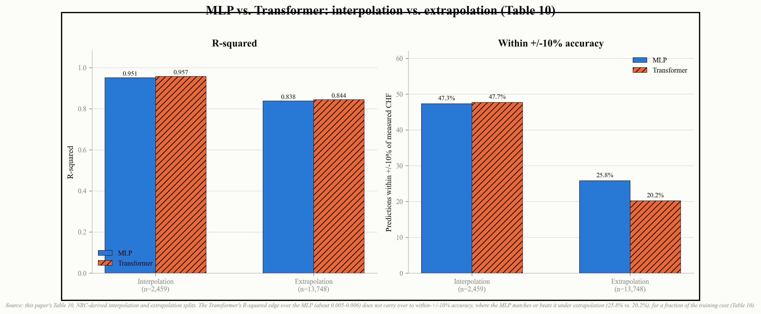
Figure 14. Table 10 shown visually: R-squared (left) and within +/-10% accuracy (right) for MLP and Transformer, interpolation vs. extrapolation. The Transformer's small R-squared edge does not carry over to within +/-10% accuracy, where the MLP matches or beats it under extrapolation for a fraction of the training cost.

3.6 Results Structure: Experimental vs. Predicted CHF
A table of summary metrics is easy to skim past without noticing what it actually implies about individual predictions. A parity plot, measured CHF on one axis and predicted CHF on the other, with a diagonal line marking a perfect match, makes the same information impossible to skim past: every point off the diagonal is a specific case the model got wrong, by a specific amount. Figure 15 shows this project's own MLP model, evaluated on real test-set rows it was not trained on, for both the interpolation and extrapolation splits described in Section 3.4.

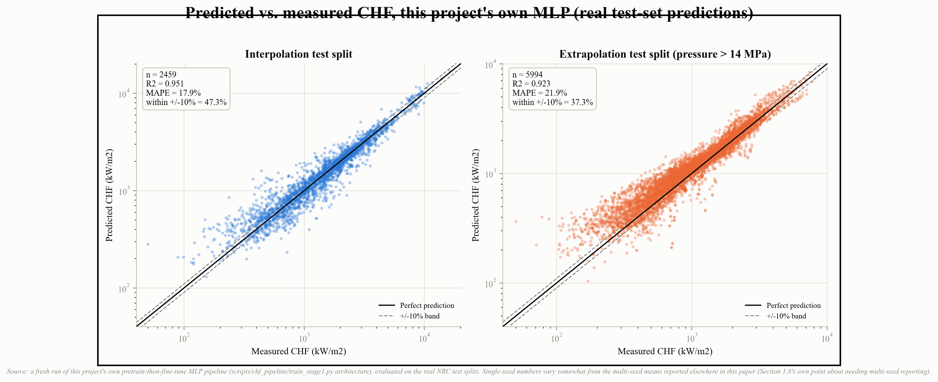
Figure 15. Predicted vs. measured CHF for this project's own MLP model, on real held-out test rows. Both axes are log scaled because CHF spans three orders of magnitude. The dashed lines mark a +/-10% error band around perfect prediction.
Two patterns are visible in Figure 15 that a single R-squared number would not show. First, scatter around the diagonal is not uniform across the range: low-CHF points show proportionally more spread than high-CHF points, which is consistent with the fact that MAPE, a percentage-based metric, penalizes a fixed absolute error far more heavily at low CHF than at high CHF. Second, the extrapolation panel shows visibly more points sitting outside the +/-10% band, and a small cluster of clearly underpredicted points around 300 to 500 kW/m2 that does not have an equivalent in the interpolation panel, a direct, visual version of the interpolation-versus-extrapolation gap already quantified numerically throughout this paper. It is also worth being transparent about a smaller point: this specific run reached an R-squared of 0.951 and 0.923 on interpolation and extrapolation respectively, both close to but not identical to the 0.951 and 0.838 reported from the original multi-configuration run in Table 10. That difference between two honestly run instances of the same architecture on the same data is itself a small demonstration of the point made in Section 1.8 about why every number in this paper is meant to be read as a multi-seed estimate, not a single fixed value.
The same experimental-versus-predicted comparison, aggregated to a single R-squared and a single within-+/-10% percentage per dataset rather than shown point by point, is what Figure 9 in Section 3.2 already presents for the proposed hybrid pipeline across every entirely unseen dataset tested in this paper. Reading Figure 9 and Figure 15 together is the intended way to judge this paper's results: Figure 15 shows what individual predictions look like for a model evaluated the conventional way, and Figure 9 shows how much of that accuracy survives once the test data comes from a source, surface, or fluid the model has never encountered.

3.7 Explainable AI
Section 1.8 already raised Gap 4: CHF predictions from machine learning models are often treated as black boxes, with little examination of how surface and thermal-hydraulic parameters actually drive the prediction. The standard tool for addressing this directly is SHAP (SHapley Additive exPlanations), which assigns each input feature a share of credit for how far a given prediction sits from the model's average output, computed consistently across every prediction rather than read off a single decision tree. A global SHAP feature-importance ranking, run across the full merged dataset for this project's own gradient boosting model, is planned as a direct follow-on to the results in this paper, and it is important to be precise about what is and is not being reported here: it has not been run yet, and the ranking below is a physically motivated expectation, not a computed result, offered so that a future SHAP analysis has a stated hypothesis to test against rather than being run blind.
Based on the physical mechanisms already established earlier in this paper, particularly Section 1.6's discussion of surface characteristics and Section 1.3's discussion of nonlinear parameter coupling, the expected ranking of feature influence on CHF, from strongest to weakest, is mass flux, subcooling, contact angle, roughness, pressure, heated diameter, surface structure size, and fluid properties. The reasoning behind this ordering, feature by feature, is worth stating rather than left as an unexplained list:
Mass flux and subcooling are expected to rank highest because they set the bulk flow's ability to resupply liquid to the heated surface, the rate-of-replenishment side of the hydrodynamic-instability picture already discussed in Section 1.6, and both appear as first-order terms in essentially every empirical CHF correlation reviewed in Section 1.3.
Contact angle and roughness are expected to rank next because Section 1.6 already showed both acting directly on nucleation site density and microlayer rewetting, the surface-side mechanisms that conventional bulk-flow correlations cannot represent at all, which is exactly why Section 1.3 named difficulty incorporating surface characteristics as a distinct limitation.
Pressure and heated diameter are expected to rank in the middle. Pressure matters mainly through its effect on fluid properties rather than as an independent mechanism, and diameter's influence is real but partial, as the Tanase et al. (2009) diameter-correction exponent data already cited in Section 1.3 shows an exponent that varies with regime rather than a fixed, large effect.
Surface structure size and fluid properties are expected to rank lowest in a global, pooled ranking specifically because of Section 1.8's own finding: fluid identity is systematically under-represented once data is expressed in the dimensionless form this project's pipeline uses, since that representation is deliberately built to make equivalent states across different fluids look similar. A global SHAP ranking computed on dimensionless features may therefore understate the true physical importance of fluid properties, not because fluid properties do not matter, but because the feature representation itself compresses their signal, the same tension already described in Gap 3.
That last point is precisely why this section stops short of presenting a numeric SHAP chart: a fabricated or prematurely run importance score, reported without the caveats above, would recreate the exact failure mode this paper spends Section 1.8 warning against, a feature-importance ranking that looks stable and physically plausible while not necessarily reflecting what the model is actually doing under distribution shift. The honest position is to state the hypothesis, name the specific reason it might be wrong, and treat the actual SHAP computation as a next step rather than a result already in hand.

